|  |  |  |  |  |
| --- | --- | --- | --- | --- |
|  |  | | |  |
| HUAWEI CLOUD | | |
| Moodle Delivery Guide  ECS Cluster Solution | | |
| Issue | 1.2 | |
| Date | Sep 21, 2022 | |
| 方圆ok1 | | | | |
|  | HUAWEI TECHNOLOGIES CO., LTD. | | 附件1-16K |  |

|  |
| --- |
| **Copyright © Huawei Technologies Co., Ltd. 2022. All rights reserved.**  No part of this document may be reproduced or transmitted in any form or by any means without prior written consent of Huawei Technologies Co., Ltd.  **Trademarks and Permissions**  附件3-图 and other Huawei trademarks are trademarks of Huawei Technologies Co., Ltd.  All other trademarks and trade names mentioned in this document are the property of their respective holders.  **Notice**  The purchased products, services and features are stipulated by the contract made between Huawei and the customer. All or part of the products, services and features described in this document may not be within the purchase scope or the usage scope. Unless otherwise specified in the contract, all statements, information, and recommendations in this document are provided "AS IS" without warranties, guarantees or representations of any kind, either express or implied.  The information in this document is subject to change without notice. Every effort has been made in the preparation of this document to ensure accuracy of the contents, but all statements, information, and recommendations in this document do not constitute a warranty of any kind, express or implied. |

|  |
| --- |
| Huawei Technologies Co., Ltd. |

About this Document

Introduction

This document describes how to deploy the Moodle on HUAWEI CLOUD.

Intended Audience

This document is intended for technical engineers, who must:

* Be familiar with the basic operation commands of the Linux and Windows.
* Be familiar with operations on the HUAWEI CLOUD official website.

Symbol Conventions

The symbols that may be found in this document are defined as follows:

| Symbol | Description |
| --- | --- |
|  | Indicates a hazard with a high level of risk which, if not avoided, could result in death or serious injury. |
|  | Indicates a hazard with a medium level of risk which, if not avoided, could result in death or serious injury. |
|  | Indicates a hazard with a low level of risk which, if not avoided, could result in minor or moderate injury. |
|  | Indicates a potentially hazardous situation which, if not avoided, could result in equipment damage, data loss, performance deterioration, or unanticipated results.  This symbol does not indicate human body injuries. |
|  | Supplements the important information in the main text.  **NOTE** is used to address information not related to personal injury, equipment damage, and environment deterioration. |

Change History

| Issue | Date | Description |
| --- | --- | --- |
| 1.0 | Aug 21, 2022 | * This issue is the first official release. |
| 1.1 | Aug 22, 2022 | * Update LLD sheet and screenshot in this guide. |
|  |  |  |
|  |  |  |

Contents

[About this Document ii](#_Toc112013432)

[Contents 4](#_Toc112013433)

[1 Overview 7](#_Toc112013434)

[1.1 Solution Architecture 7](#_Toc112013435)

[1.2 Delivery Procedure Overview 8](#_Toc112013436)

[2 Preparing Keys & Tools 8](#_Toc112013437)

[2.1 Register Huawei Cloud Account 8](#_Toc112013438)

[2.2 Obtain Access Keys 9](#_Toc112013439)

[2.3 Authorize CTS Service on CTS console 9](#_Toc112013440)

[2.3.1 Click “Cloud Trace Service” on Huawei Cloud console 10](#_Toc112013441)

[2.3.2 Click “Enabled and Authorize” 10](#_Toc112013442)

[2.4 Generate SSH Key 10](#_Toc112013443)

[2.4.1 What Is SSH Key? 10](#_Toc112013444)

[2.4.2 Option 1: Generate the SSH Key Pair in Linux Server 10](#_Toc112013445)

[2.4.3 Option 2: Generate the SSH Key Pair in Windows 11](#_Toc112013446)

[2.5 Prepare the SSL Certificate 11](#_Toc112013447)

[2.6 Install Terraform Tool 13](#_Toc112013448)

[2.6.1 Download and decompress terraform 13](#_Toc112013449)

[2.6.2 Configuring Environment Variables 14](#_Toc112013450)

[3 Preparing Environment 16](#_Toc112013451)

[3.1 Download automation scripts & LLD from Gitlab 16](#_Toc112013452)

[3.2 Copy the SSH Key 19](#_Toc112013453)

[3.3 Update the LLD 19](#_Toc112013454)

[3.3.1 What’s LLD? 19](#_Toc112013455)

[3.3.2 Select Country (Mandatory) 21](#_Toc112013456)

[3.3.3 Update the Keys (Mandatory) 21](#_Toc112013457)

[3.3.4 Update the Project Information (Mandatory) 21](#_Toc112013458)

[3.3.5 Update Region & AZ (Mandatory) 21](#_Toc112013459)

[3.3.6 Update the Notification Email address (Mandatory) 21](#_Toc112013460)

[3.3.7 Update Network parameters (Optional) 21](#_Toc112013461)

[3.3.8 Update Server parameters (Optional) 21](#_Toc112013462)

[3.3.9 Update Backup parameters (Optional) 21](#_Toc112013463)

[4 Building & Verifying Environment 21](#_Toc112013464)

[4.1 Enable Developer Tab in Excel 21](#_Toc112013465)

[4.2 Building Environment 23](#_Toc112013466)

[4.2.1 Enable macros when the Message Bar appears 23](#_Toc112013467)

[4.2.2 Click the “Resource Provisioning” 23](#_Toc112013468)

[4.3 Verifying Environment 25](#_Toc112013469)

[4.3.1 VPC 25](#_Toc112013470)

[4.3.2 Subnet 26](#_Toc112013471)

[4.3.3 Security group 27](#_Toc112013472)

[4.3.4 ECS 27](#_Toc112013473)

[4.3.5 Private Image (IMS) 28](#_Toc112013474)

[4.3.6 EVS 28](#_Toc112013475)

[4.3.7 CBR 28](#_Toc112013476)

[4.3.8 Cloud Eye 29](#_Toc112013477)

[4.3.9 Cloud Trace Service (CTS) 30](#_Toc112013478)

[4.3.10 Simple Message Notification (SMN) 30](#_Toc112013479)

[4.3.11 SSL Certificate Manager (SCM) 30](#_Toc112013480)

[4.3.12 Dedicated Load Balancer (ELB) 31](#_Toc112013481)

[4.3.13 NAT Gateway (NATGW) 31](#_Toc112013482)

[4.3.14 Auto Scaling (AS) 32](#_Toc112013483)

[4.3.15 RDS for MySQL (RDS MySQL) 33](#_Toc112013484)

[4.3.16 DCS for Redis (DCS Redis) 33](#_Toc112013485)

[4.3.17 Check the Status of the Moodle Application 34](#_Toc112013486)

[5 Configure Cloud Service 34](#_Toc112013487)

[5.1 Subscribe the SMN Topic 34](#_Toc112013488)

[5.2 Moodle Installation 35](#_Toc112013489)

[5.3 Moodle Configuration 39](#_Toc112013490)

[5.4 Cron Configuration 41](#_Toc112013491)

[6 FAQs 42](#_Toc112013492)

[6.1 How to remote login Linux Server via ssh from Windows? 42](#_Toc112013493)

[6.2 How to set the root user password for Linux Server 43](#_Toc112013494)

[6.3 After I click “Resource Provisioning”, what actions does the tool automatically perform? 44](#_Toc112013495)

[6.4 I want to release all the resources which are created by terraform, how to perform automatically? 46](#_Toc112013496)

[6.5 I don’t have EXCEL in my laptop, and I am familiar with Linux, how to build the environment in Linux OS? 47](#_Toc112013497)

# Overview

## Solution Architecture

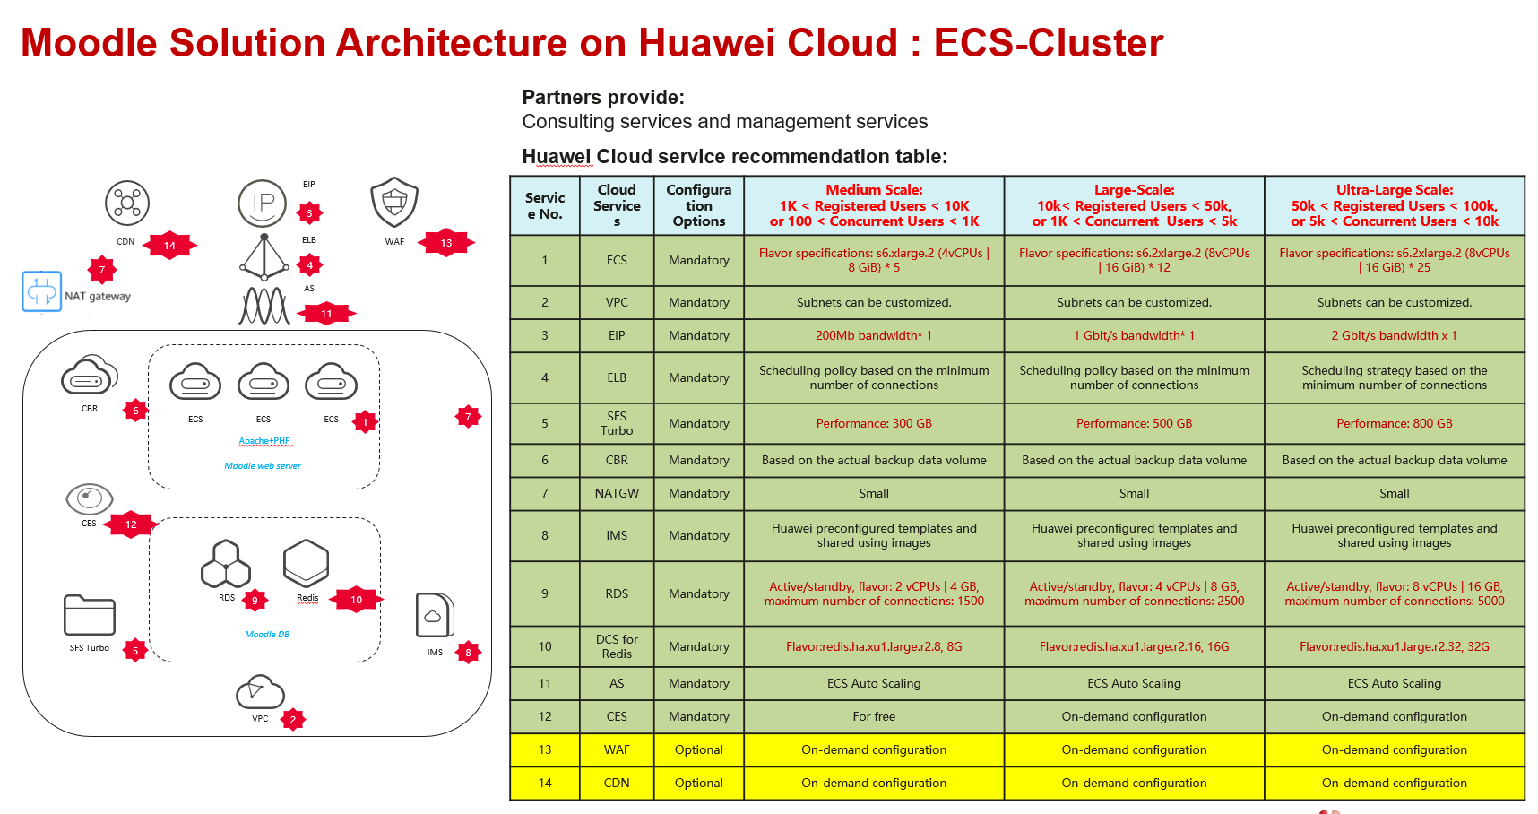

## Delivery Procedure Overview

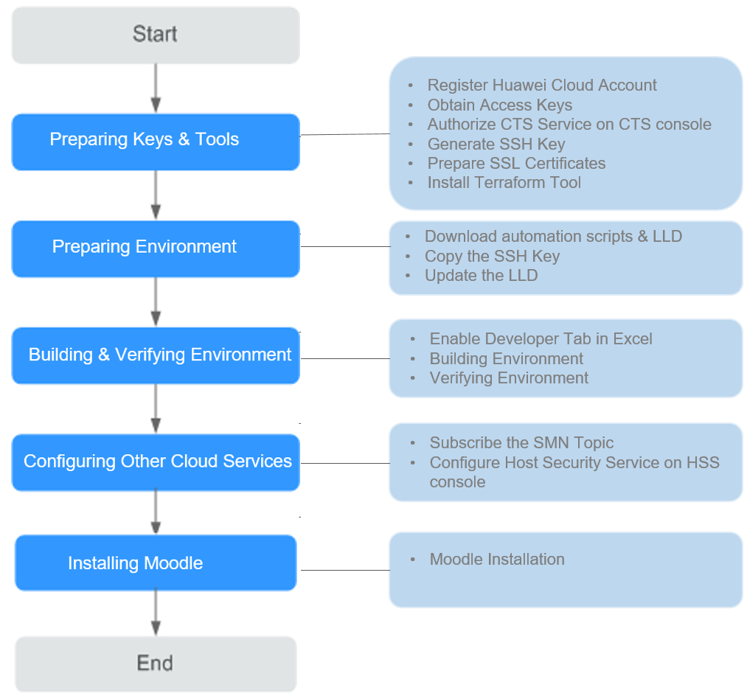

# Preparing Keys & Tools

Partners or customers need to log in to the HUAWEI CLOUD official website to register a HUAWEI CLOUD account and prepare delivery data.

## Register Huawei Cloud Account

Account Registration Process

https://support.huaweicloud.com/intl/en-us/usermanual-account/en-us\_topic\_0069252244.html

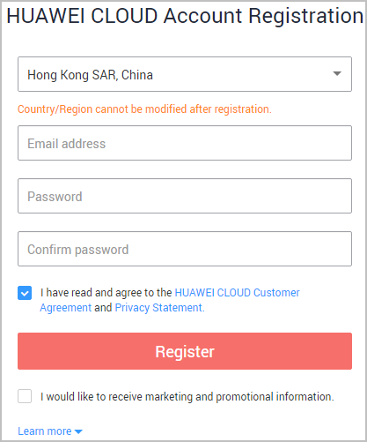 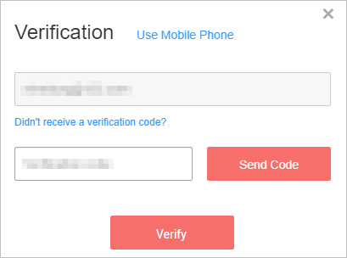

## Obtain Access Keys

An access key comprises an access key ID (AK) and secret access key (SK), and is used as a long-term identity credential to sign your API requests. AK is used together with SK to sign requests cryptographically, ensuring that the requests are secret, complete, and correct.

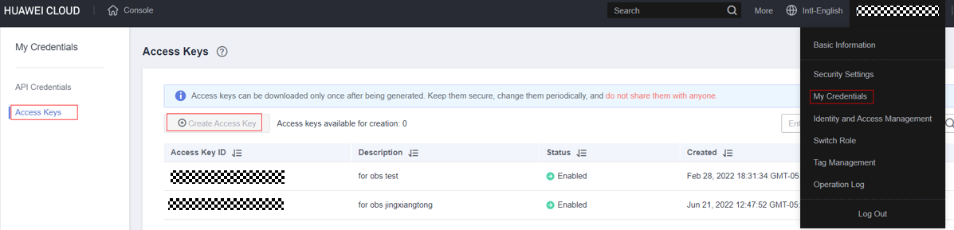



Access keys can be downloaded only once after being generated. Keep them secure, change them periodically, and do not share them with anyone.

## Authorize CTS Service on CTS console

In this solution, CTS will be used for auditing. And CTS must have the permission to access OBS and SMN. So we should authorize the permission on CTS console

### Click “Cloud Trace Service” on Huawei Cloud console

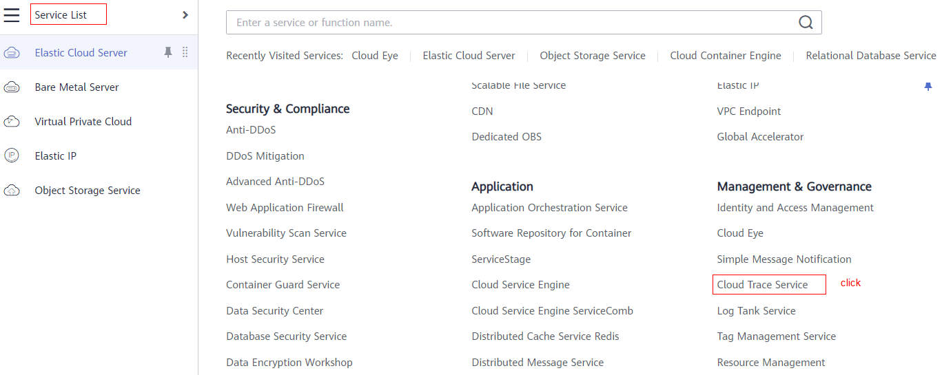

### Click “Enabled and Authorize”

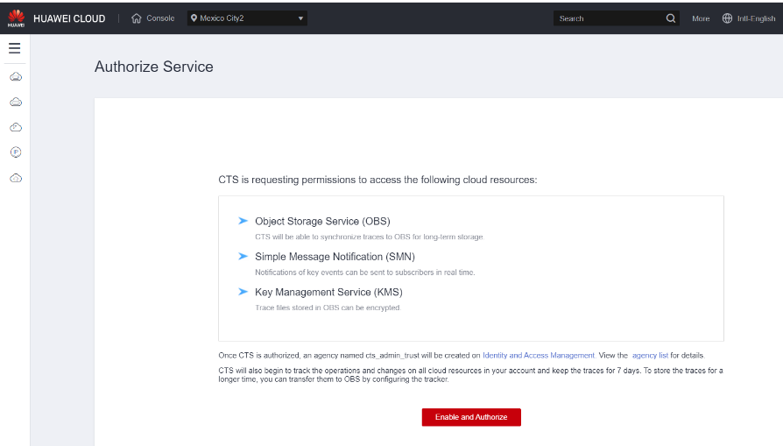

## Generate SSH Key

You should prepare SSH Key with which you can login the ECS Server safely.

### What Is SSH Key?

SSH key is a secure access credential used in the Secure Shell (SSH) protocol. SSH keys use key pairs based on public key infrastructure (PKI) technology, the gold standard for digital identity authentication and encryption, to provide a secure and scalable method of authentication.

### Option 1: Generate the SSH Key Pair in Linux Server

Step 1: Login a Linux Server

Step 2: Execute the ssh-keygen to generate the keypair

$ ssh-keygen -t rsa

Step 3: List the files

$ ls ~/.ssh

id\_rsa

id\_rsa.pub

***id\_rsa****: This file is Private Key, please keep it carefully to avoid loss.*

***id\_rsa.pub:*** *This file is Public Key, please keep it carefully to avoid loss.*

Linux Guide:

[How to use the ssh-keygen Command in Linux?](https://www.thegeekdiary.com/using-the-ssh-keygen-command-in-linux/)

### Option 2: Generate the SSH Key Pair in Windows

Windows Guide:

[How to Generate SSH Key in Windows 10](https://phoenixnap.com/kb/generate-ssh-key-windows-10)

## Prepare the SSL Certificate

SSL Certificate is for HTTPS website. We use terraform to upload certificate to SCM and push the certificate from SCM to ELB.

You should prepare the certificate files in advance.

* [certificate](https://registry.terraform.io/providers/huaweicloud/huaweicloud/latest/docs/resources/scm_certificate" \l "certificate) - (Required, String, ForceNew) The public encrypted key of the Certificate, PEM format.

* [certificate\_chain](https://registry.terraform.io/providers/huaweicloud/huaweicloud/latest/docs/resources/scm_certificate" \l "certificate_chain) - (Required, String, ForceNew) The chain of the certificate. It can be extracted from the *server.crt* file in the Nginx directory, usually after the second paragraph is the certificate chain.

* [private\_key](https://registry.terraform.io/providers/huaweicloud/huaweicloud/latest/docs/resources/scm_certificate" \l "private_key) - (Required, String, ForceNew) The private encrypted key of the Certificate, PEM format.

<https://gitlab.com/l.shaowei/huaweicloud-moodle-ecs-cluster/-/blob/main/modules/scm/main.tf>

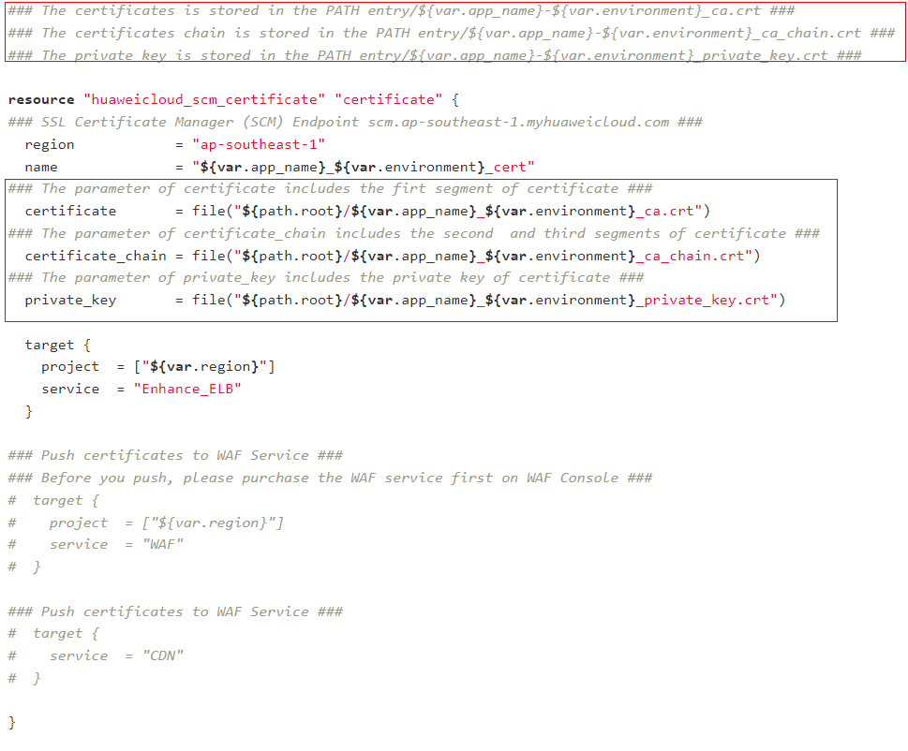

For example:

If your *var.app\_name = moodle* and *var.environment= production,* so your certificate filenames should be as below:

* moodle\_production\_ca.crt

sub-certificate (server certificate)

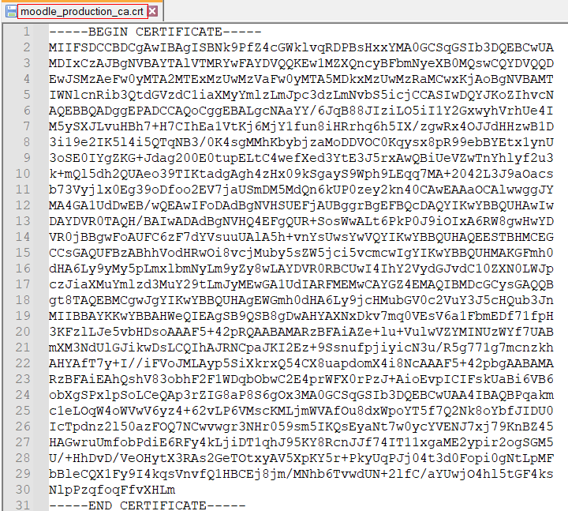

* moodle\_production\_ca\_chain.crt

Intermediate certificate & root certificate

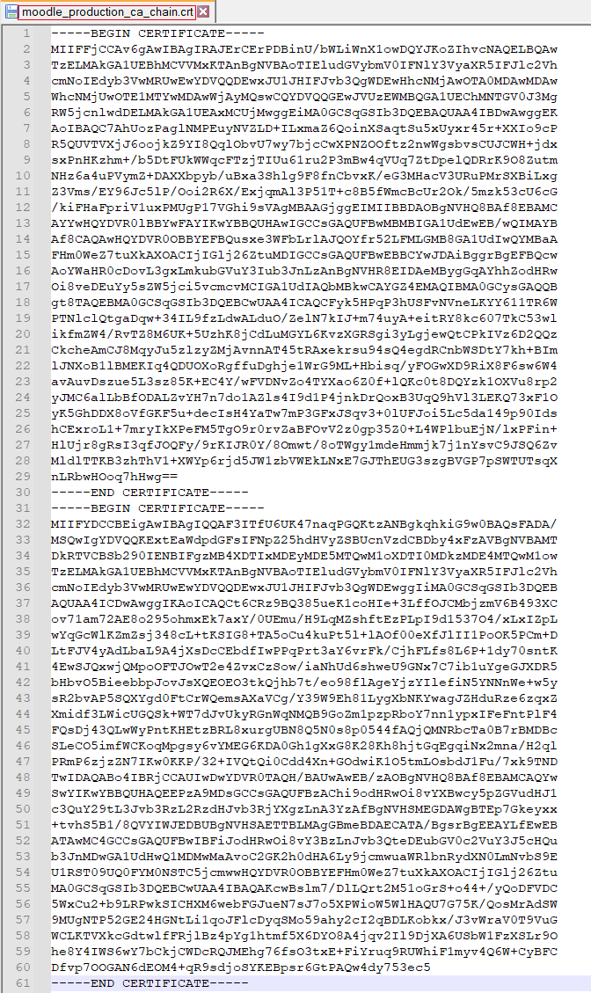

* moodle\_production\_private\_key.crt

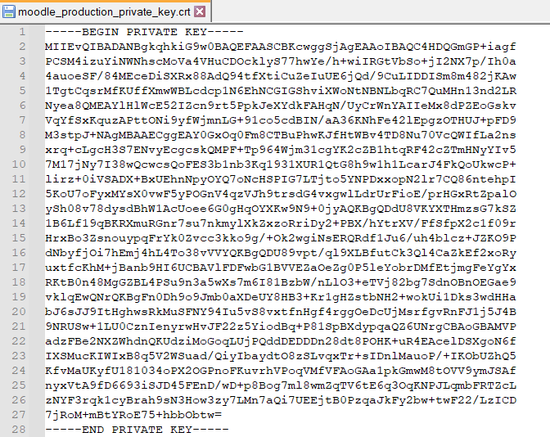

## Install Terraform Tool

### Download and decompress terraform

Open the Terraform Official Website URL <https://www.terraform.io/downloads> , and download the latest terraform software for Windows.



Extract the package to the *C:\Program Files\terraform directory*.

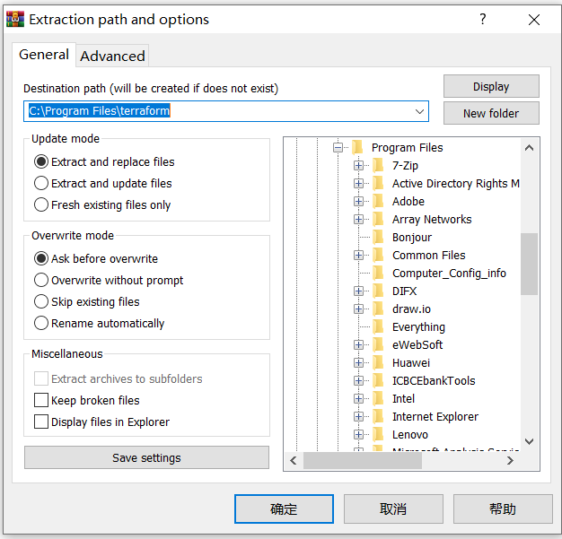

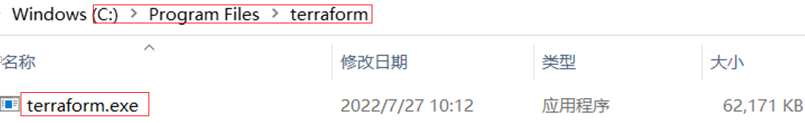

### Configuring Environment Variables

Search for the environment and open System properties panel in the control panel.

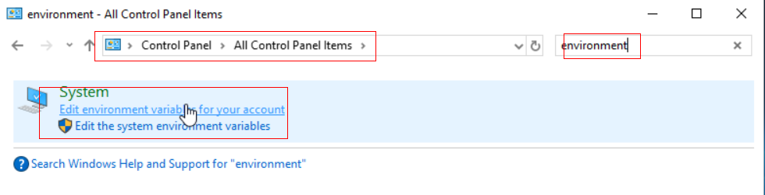

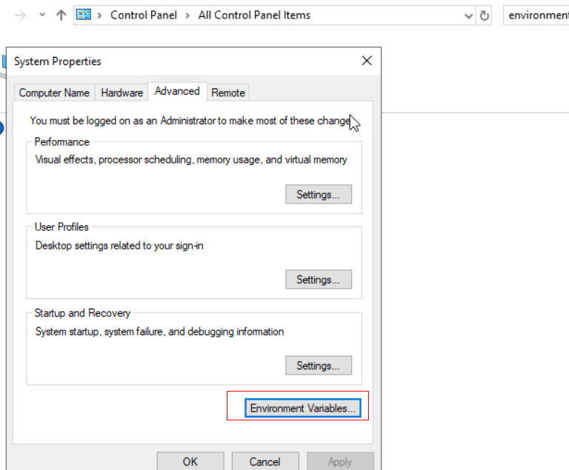

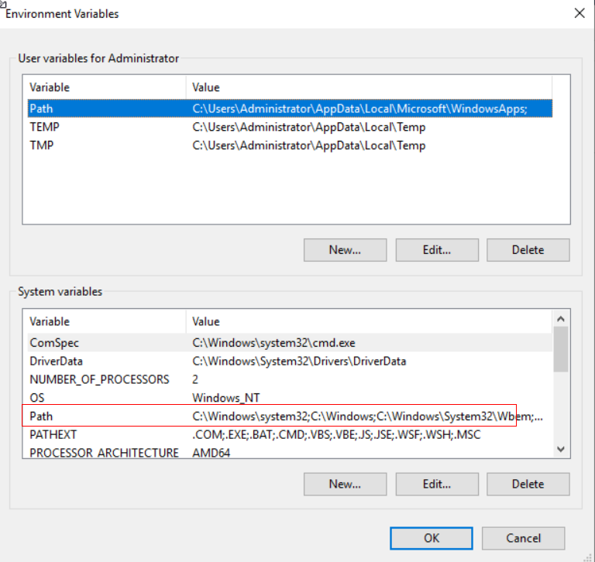

Fill this path in the box below *C:\Program Files\terraform*

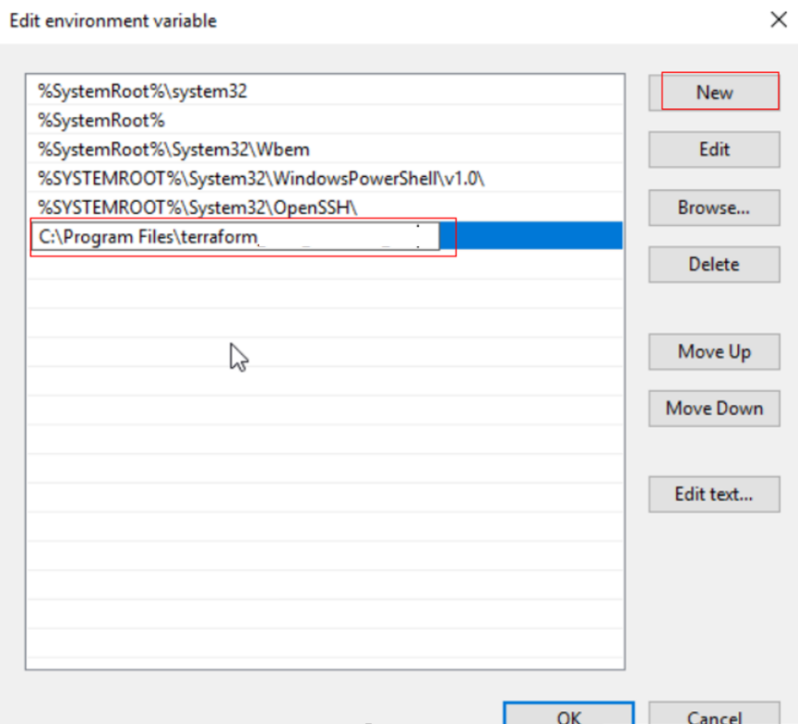

After the environment variables are configured, open the CMD window and check the terraform version. If the version can be queried, the new environment variable has taken effect.

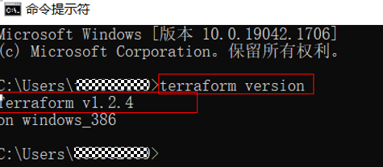

# Preparing Environment

## Download automation scripts & LLD from Gitlab

**Download link**

Solution 1: Moodle ECS Cluster installation

<https://gitlab.com/l.shaowei/huaweicloud-moodle-ecs-cluster>

<https://gitlab.com/l.shaowei/huaweicloud-moodle-ecs-cluster.git>

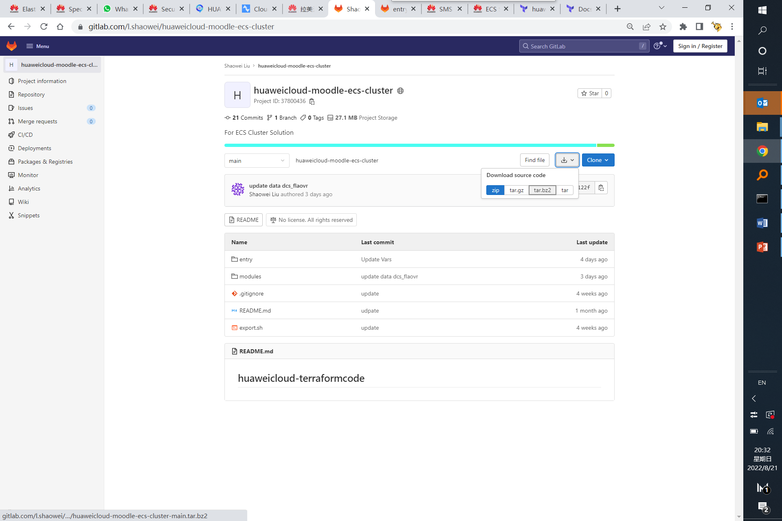

Download the zip package:



Extract the package:

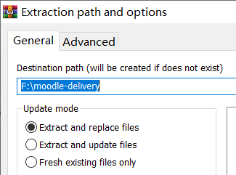

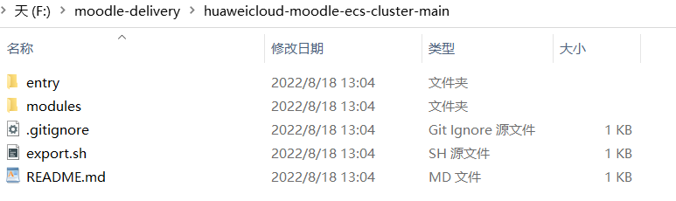

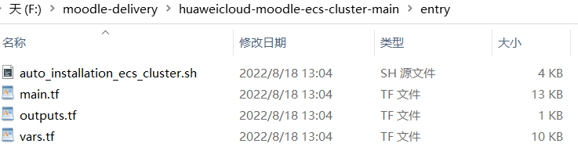

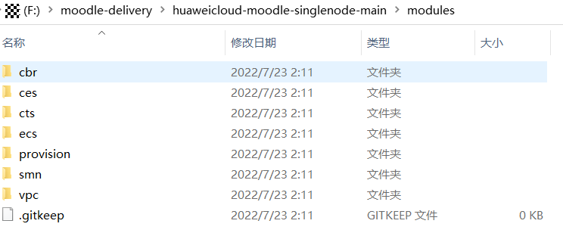

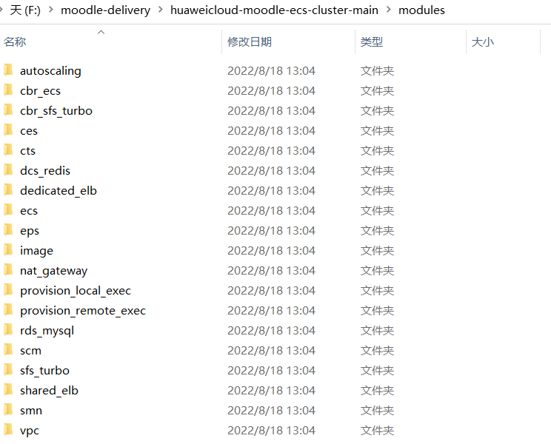

## Copy the SSH Key

Copy the private\_key\_file [**id\_rsa**] and public\_key\_file [**id\_rsa.pub**] to the [**entry]** directory.

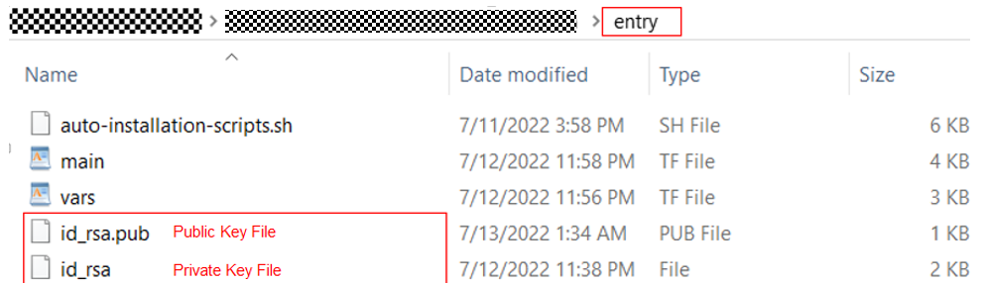

## Update the LLD

### What’s LLD?

LLD is Low Level Design in Excel. You can update the parameter in sheet “*Information Collection List*”, then Click “*Resource Provisioning*” to build the environment automatically.

If you want to generate the variables file (vars.tf) ONLY, please click the “Generate variables file (vars.tf) ONLY.

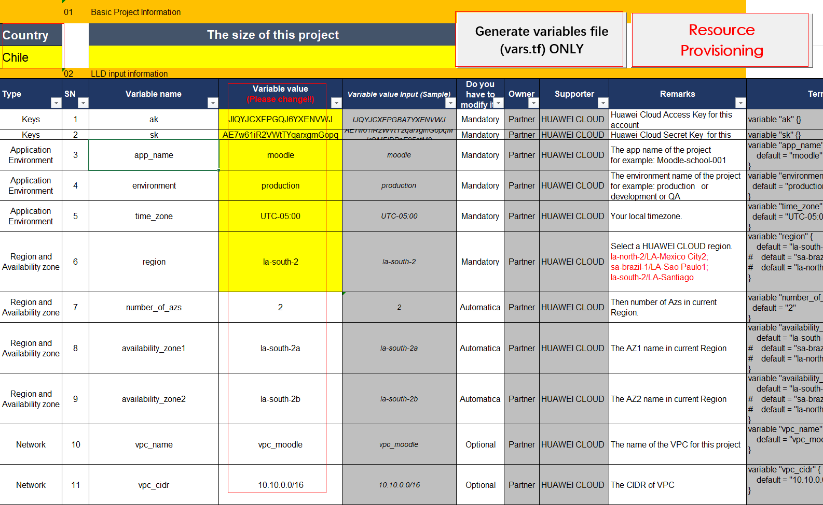

**There are so many parameters, and which one should I update?**

Totally 4 types of parameter, the description is as below:

* Mandatory: Must update according to the information of your environment.
* Optional: By default, it’s not necessary to change. But if you can change for customization.
* Automatic: VBscript will generate automatically. Don’t change.
* Default: Don’t change.

### Select Country (Mandatory)

### Update the Keys (Mandatory)

### Update the Application Environment (Mandatory)

### Update Region & AZ (Mandatory)

### Update Network (Optional)

### Security Group (Optional)

### ECS Instance (Optional)

### CBR (Optional)

### SMN (Mandatory)

### Provision (Mandatory)

### ELB (Optional)

### RDS MySQL (Mandatory)

### DCS Redis (Mandatory)

### SFS Turbo (Mandatory)

### NATGATEWAY (Optional)

### Auto Scaling (Mandatory)

# Building & Verifying Environment

## Enable Developer Tab in Excel

<https://trumpexcel.com/excel-developer-tab/>

Right-click on any of the existing tabs in the ribbon and select Customize the Ribbon. It will open the Excel Options dialogue box.

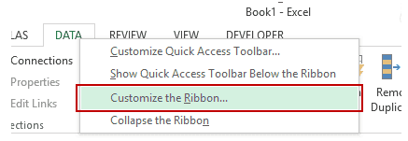

In the Excel Options dialogue box, you will have the Customize the Ribbon options. On the right, within the Main Tabs pane, check the Developer option.

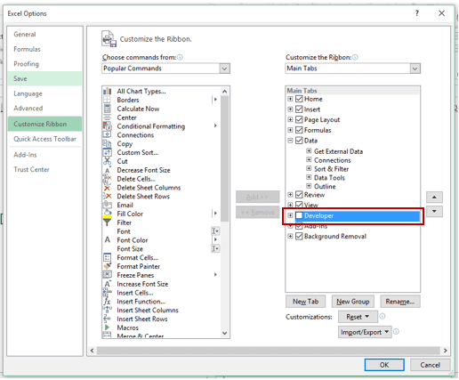

* Click OK.

Now you will have ‘Developer’ displayed as one of the tabs.

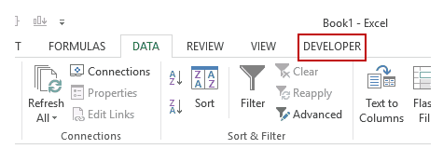

Once available, you can use this tab to access all the options within it.

## Building Environment

### Enable macros when the Message Bar appears

When you open a file that has macros, the yellow message bar appears with a shield icon and the ***Enable Content*** button. If you know the macro, or macros, are from a reliable source, use the following instructions:

On the ***Message Bar***, click ***Enable Content***.

The file opens and is a trusted document.

The following image is an example of the Message Bar when macros are in the file.



### Click the “Resource Provisioning”

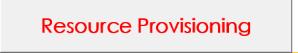

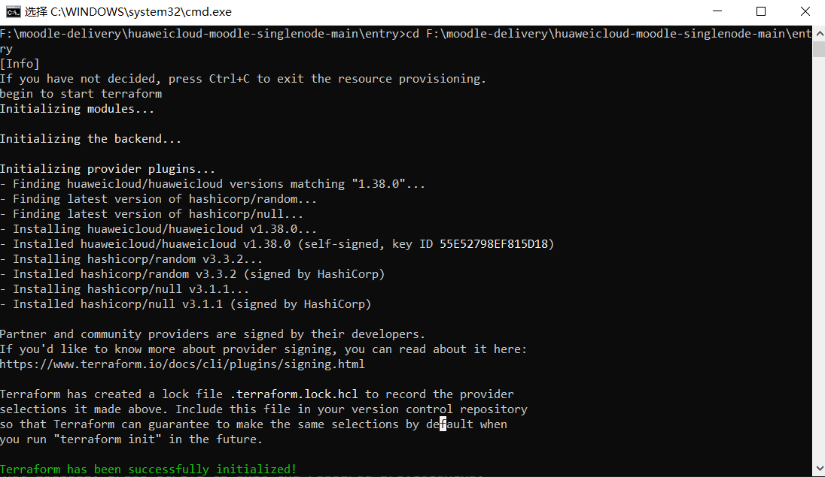

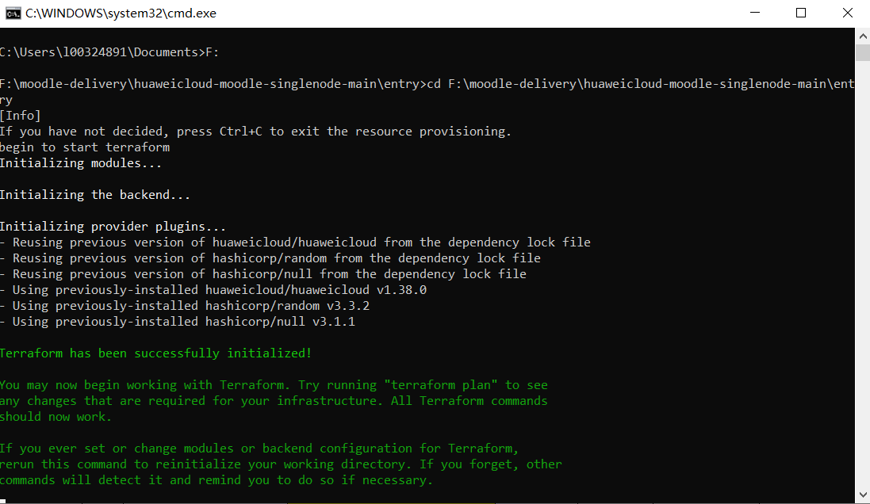

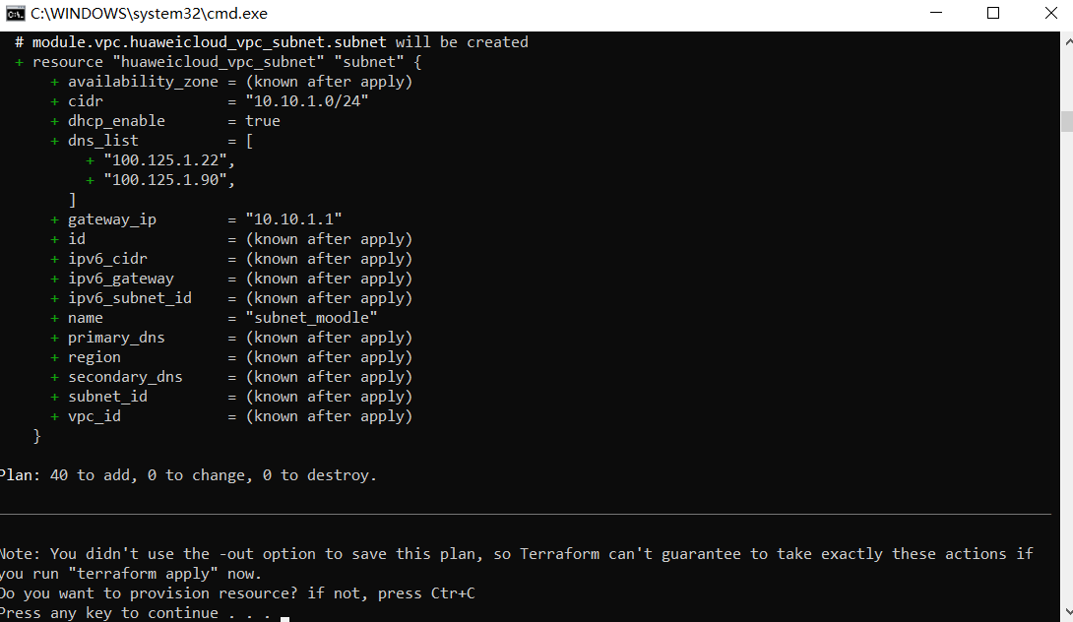

Press ***Enter*** to execute the “terraform apply”, then wait for some seconds.

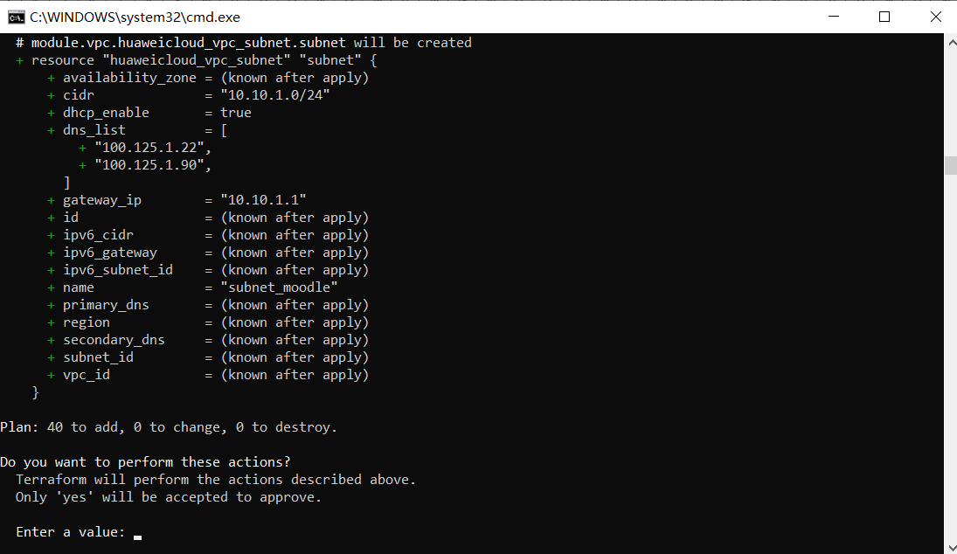

Enter a value: ***yes*** to approve the actions.

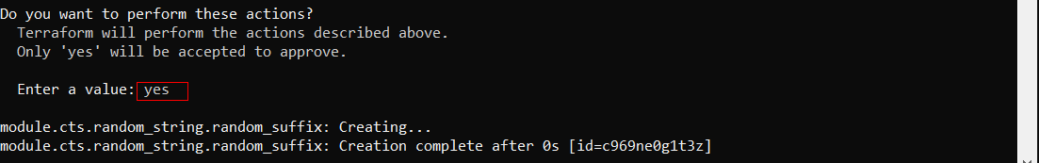

Waiting for the environment building, please hold on.

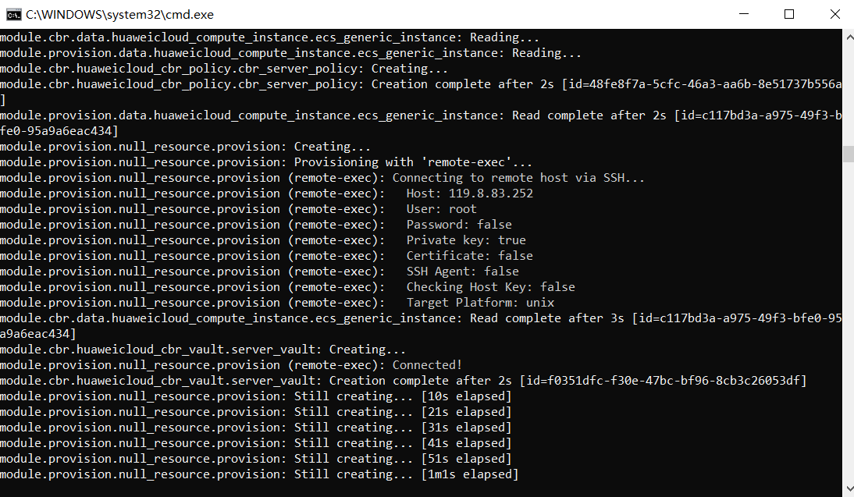

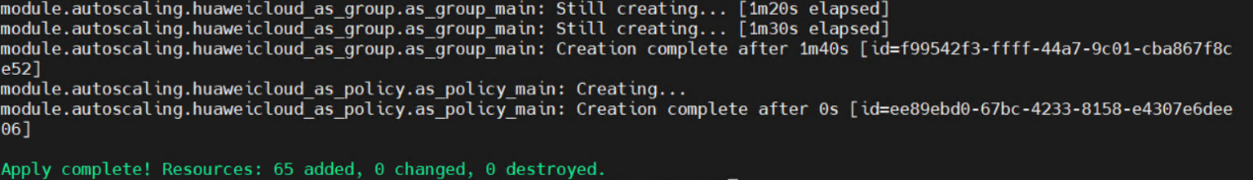

## Verifying Environment

### VPC

Verify that VPC has been created on the VPC console.

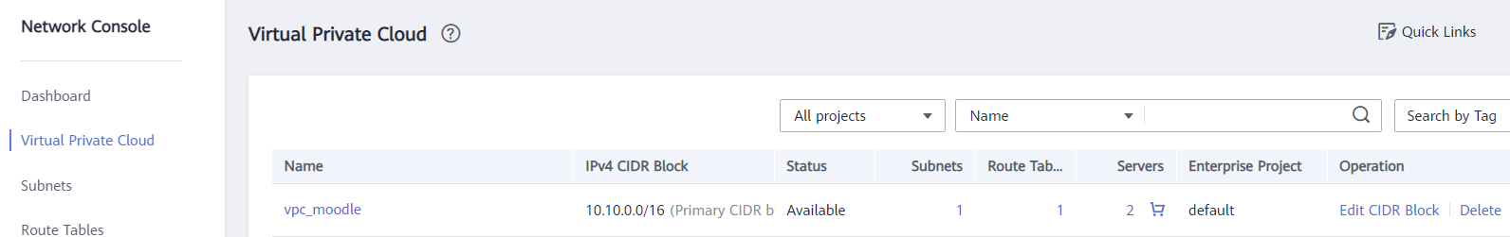

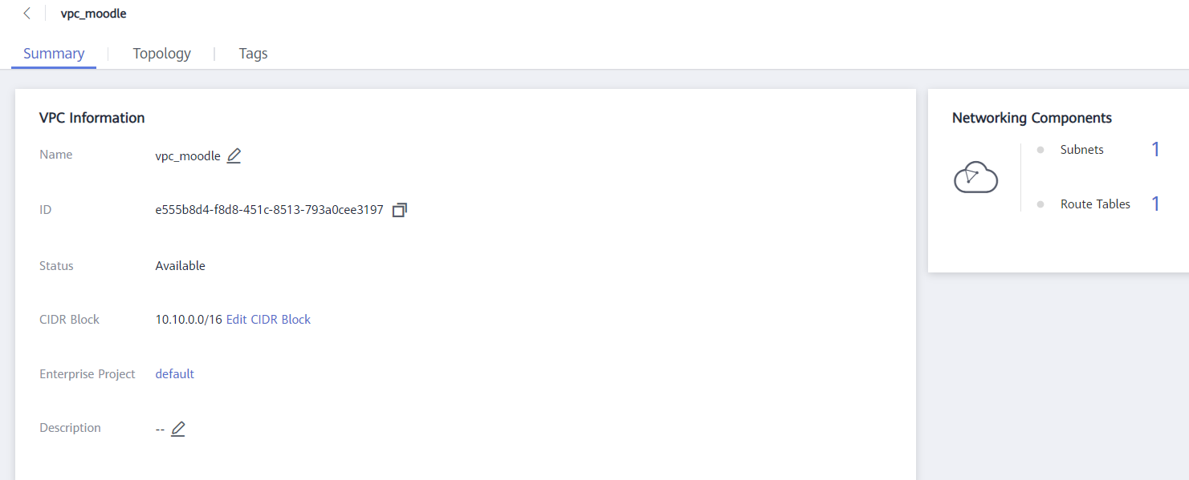

### Subnet

Verify that subnet-sapb1 has been created on the subnet console.

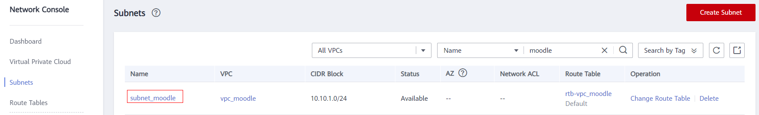

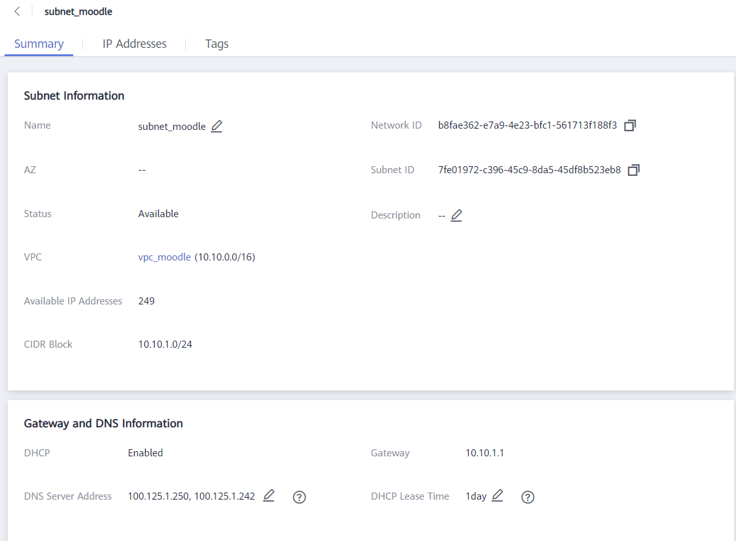

### Security group

The Security Group is created on the console of the security group.

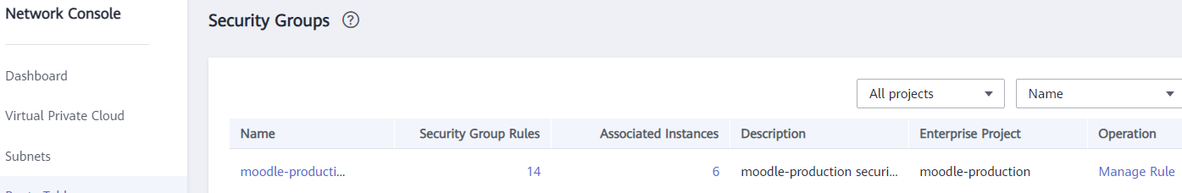

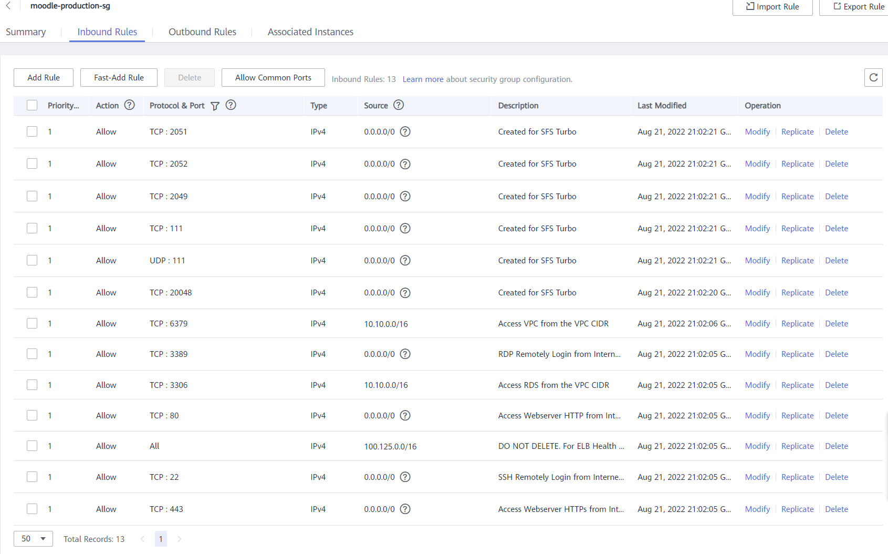

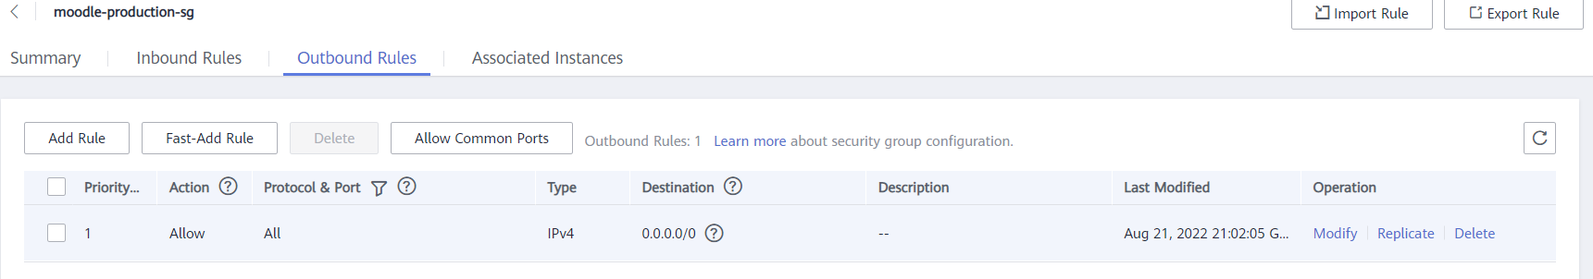

### ECS

Verify that ECS has been created on the Elastic Cloud Server console.

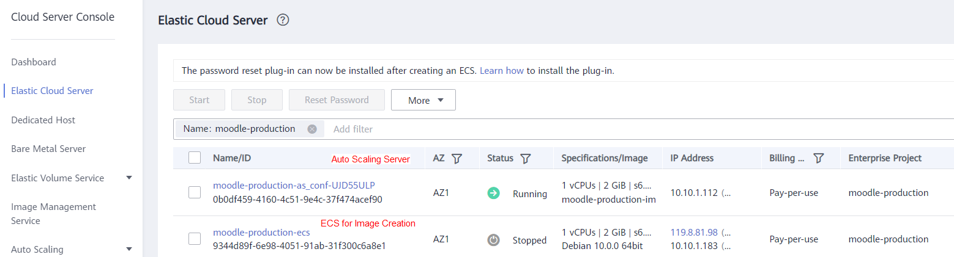

### Private Image (IMS)

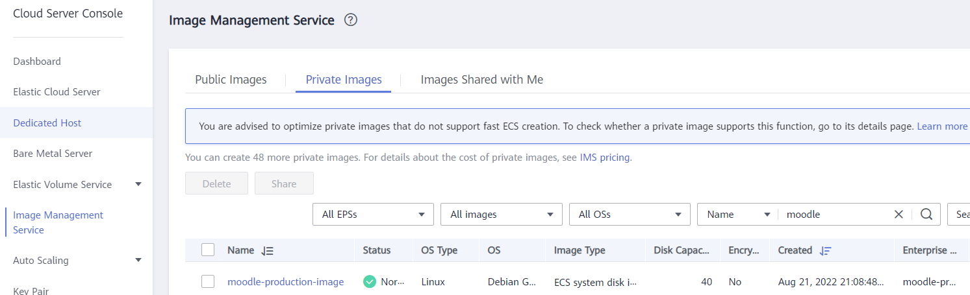

### EVS

Verify that the EVS is mounted on the ECS details page.

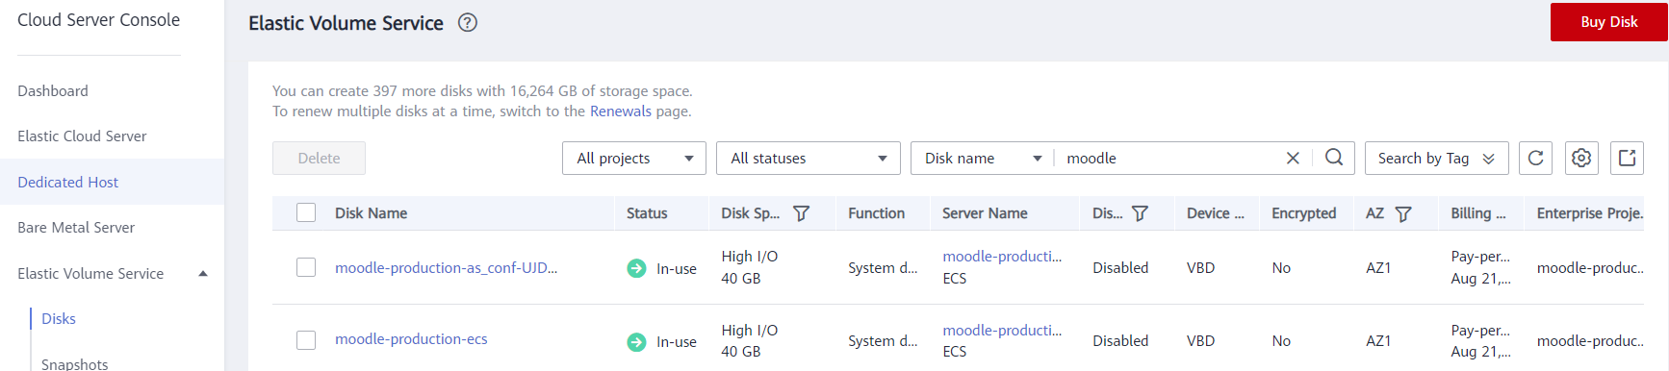

### CBR

Verify that CBR Vault is created on the CBR console.

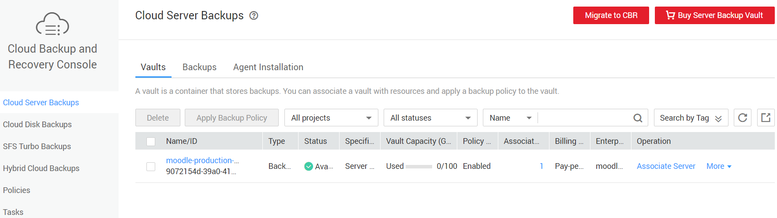

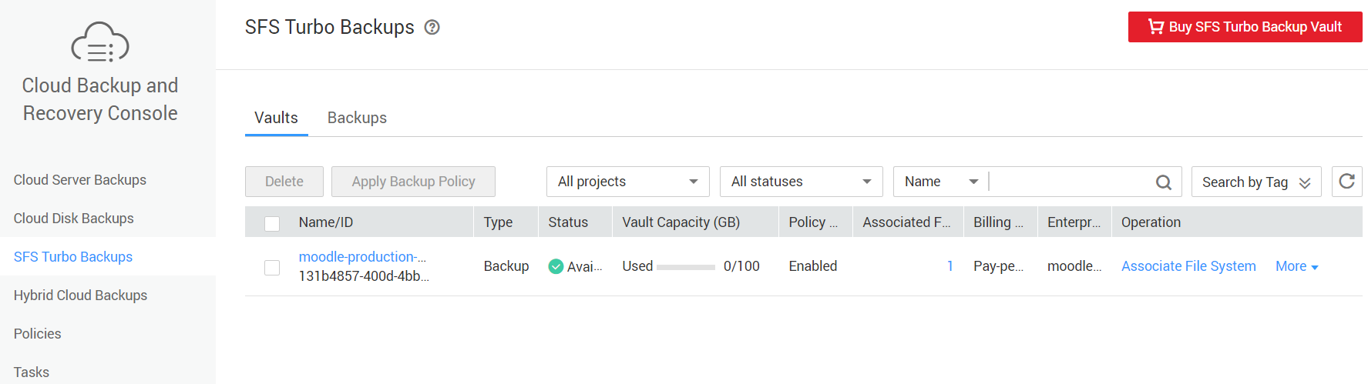

### Cloud Eye

Verify that Event Alarms is created on the Cloud Eye console.

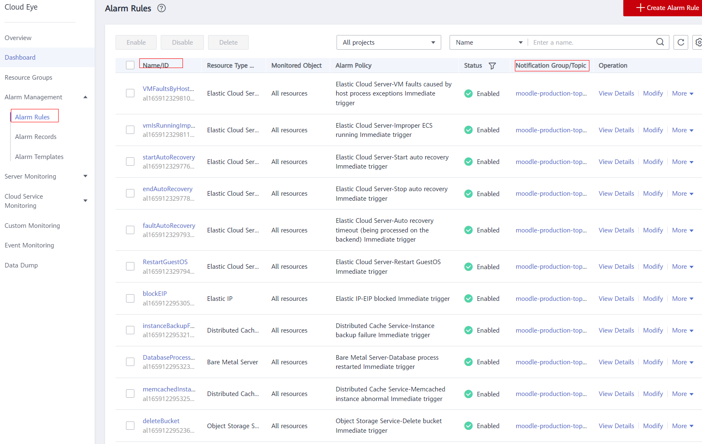

### Cloud Trace Service (CTS)

Verify that CTS is configured on the CTS console.

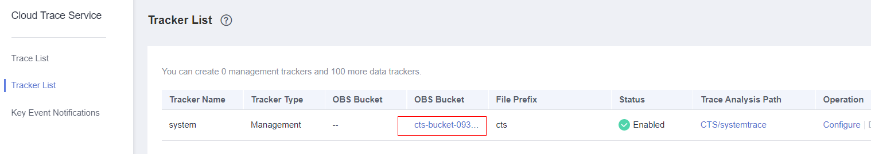

### Simple Message Notification (SMN)

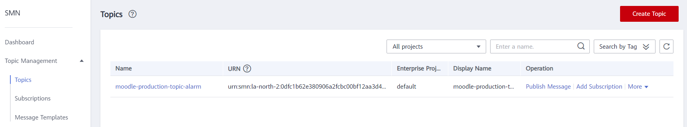

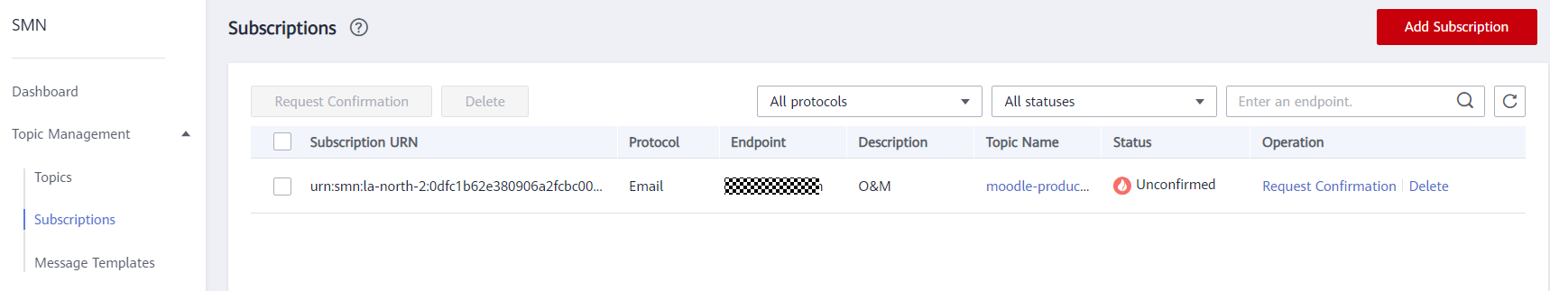

### SSL Certificate Manager (SCM)

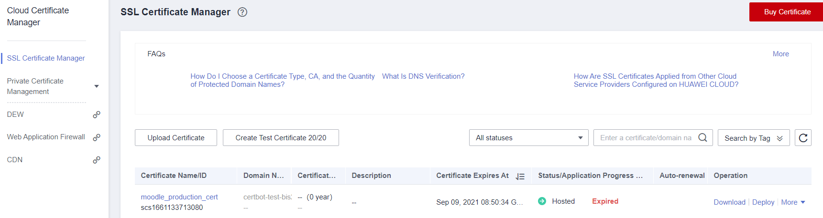

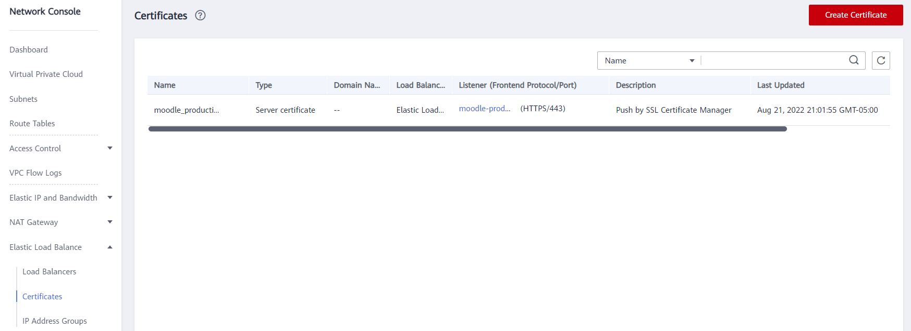

### Dedicated Load Balancer (ELB)

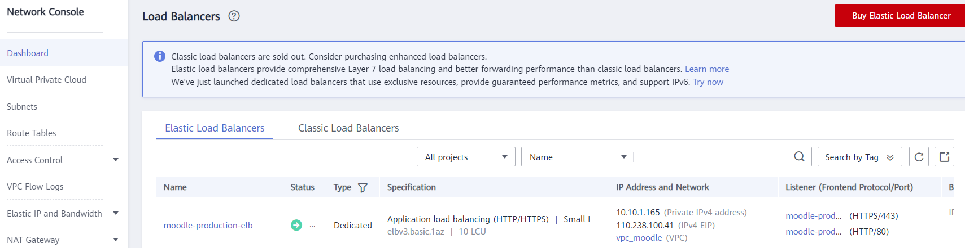

### NAT Gateway (NATGW)

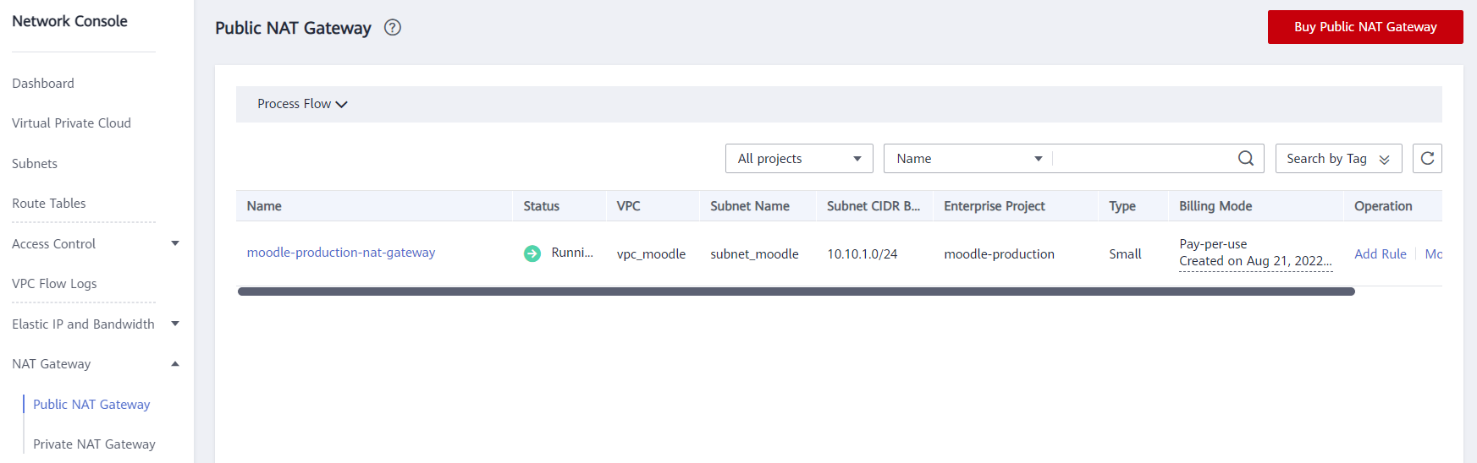

### Auto Scaling (AS)

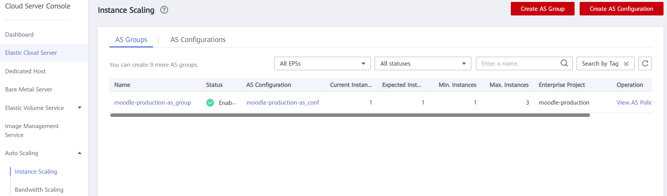

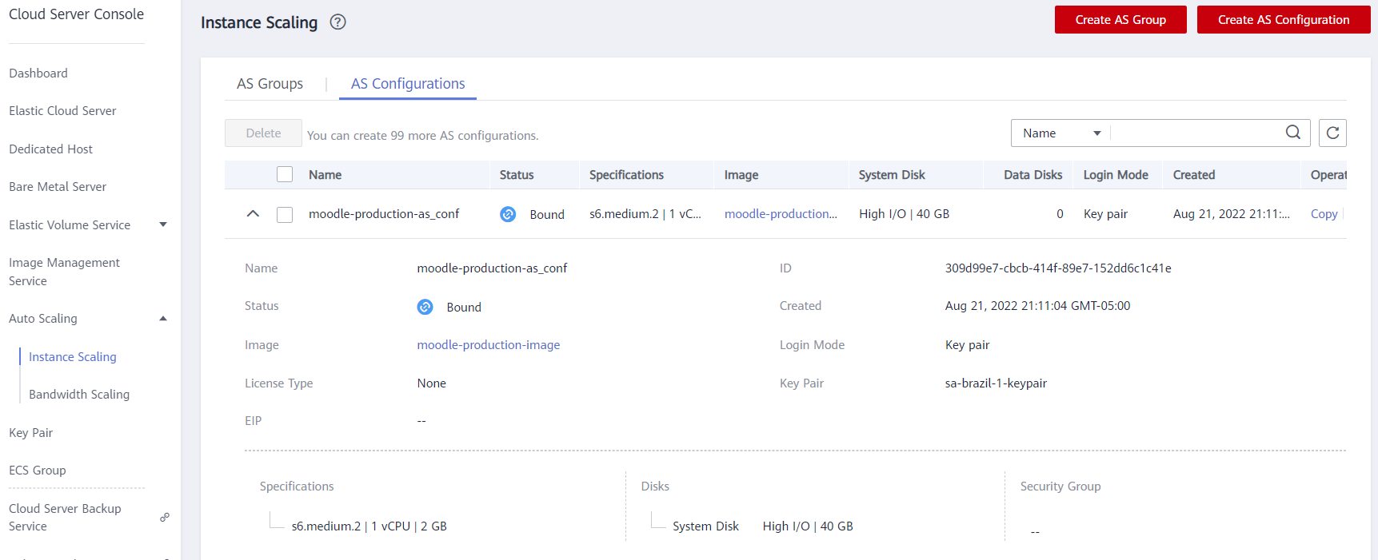

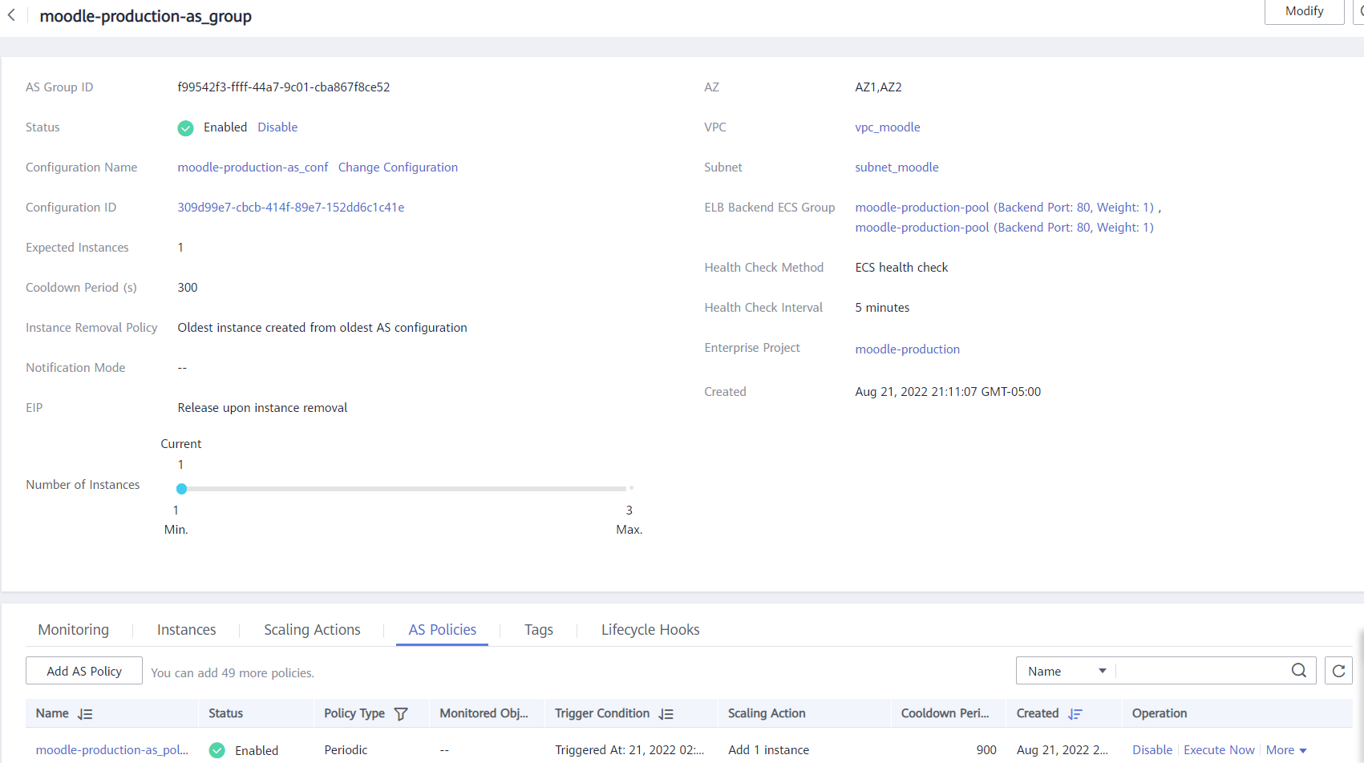

### RDS for MySQL (RDS MySQL)

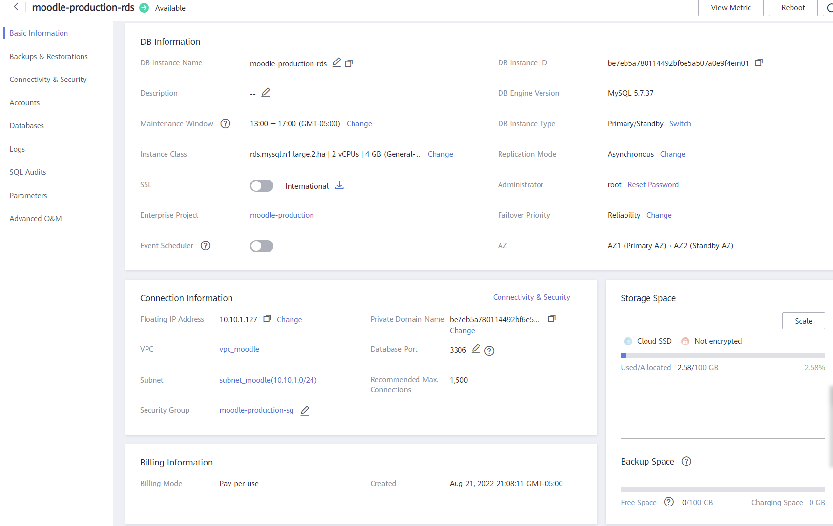

### DCS for Redis (DCS Redis)

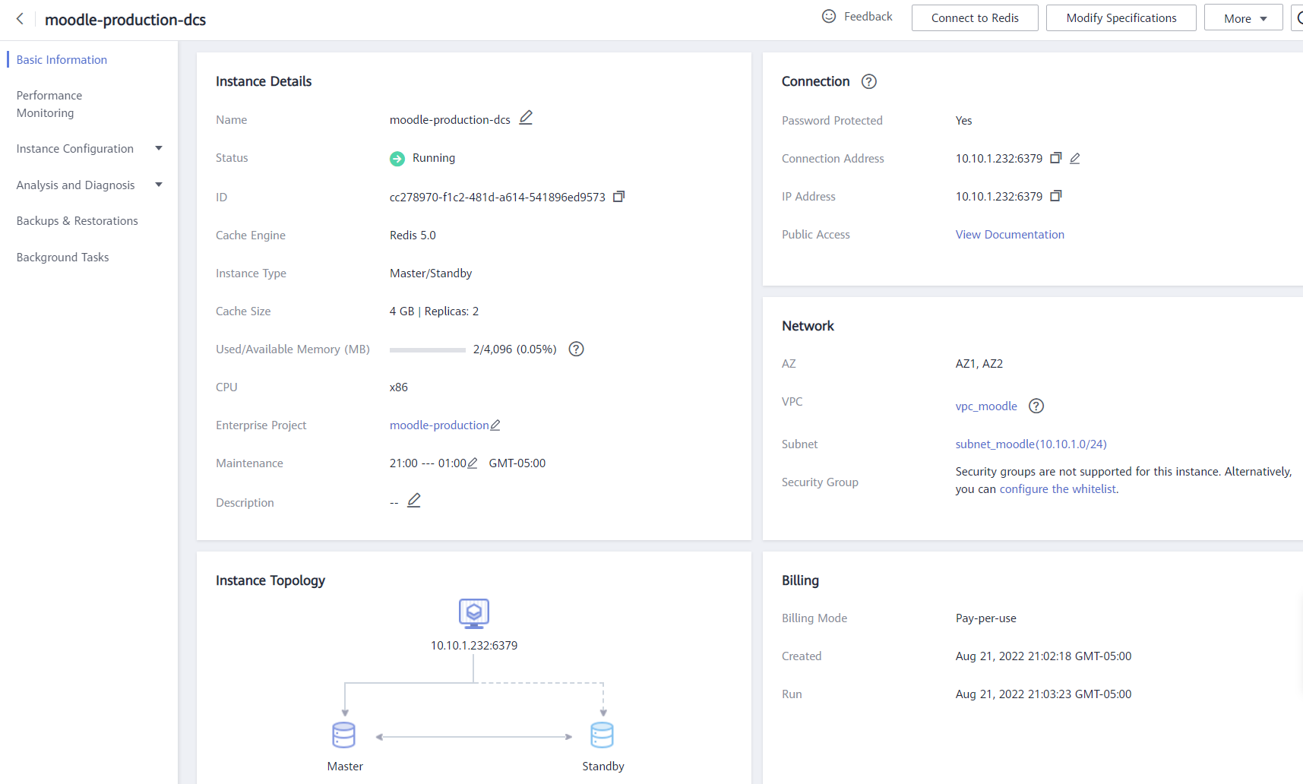

### Check the Status of the Moodle Application

* Obtain the EIP from ELB console

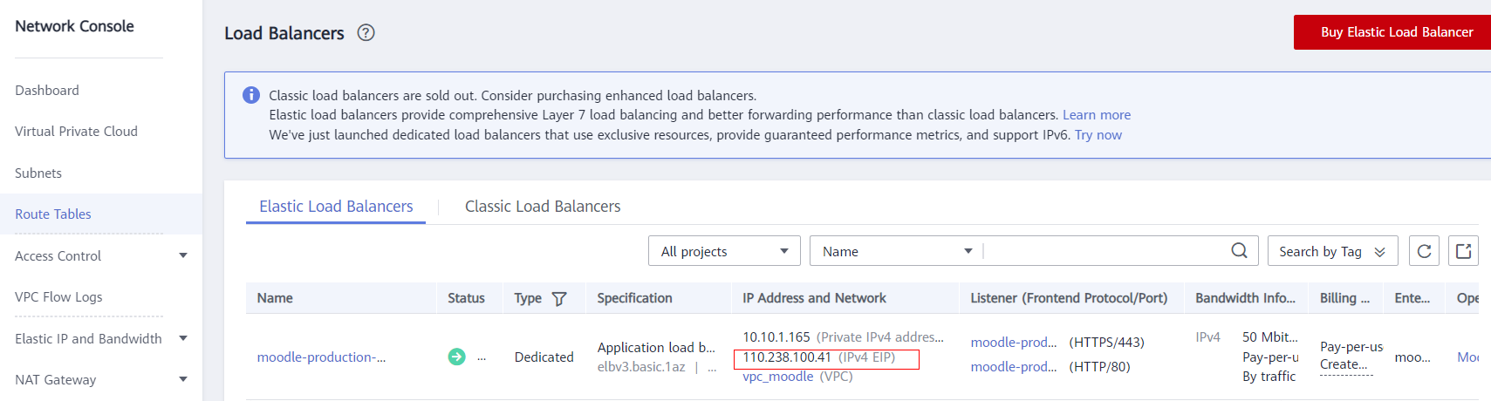

* Open the URL [http://***localhost***/install.php](http://localhost/install.php) in Chrome Browser

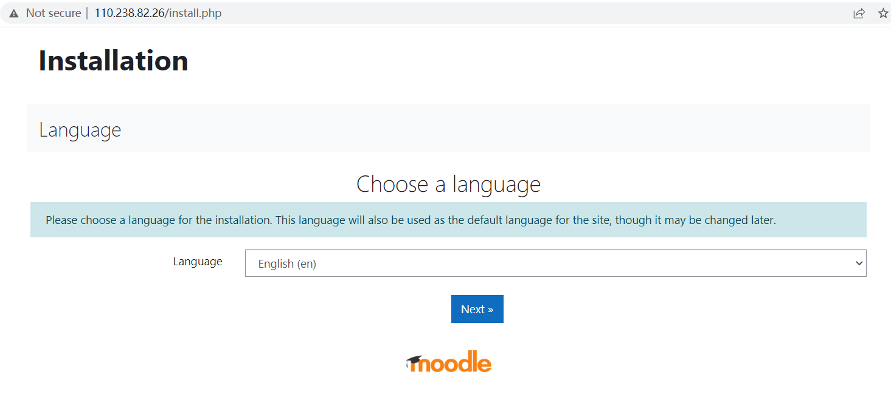

* (Optional) If you cannot open the Moodle Installation Page, please check the /tmp/auto.log in ECS for troubleshooting.



# Configure Cloud Service

## Subscribe the SMN Topic

Login your email to click the Subscription URL link.

Then you can receive the Cloud Eye Event Alarm when there is alarm.

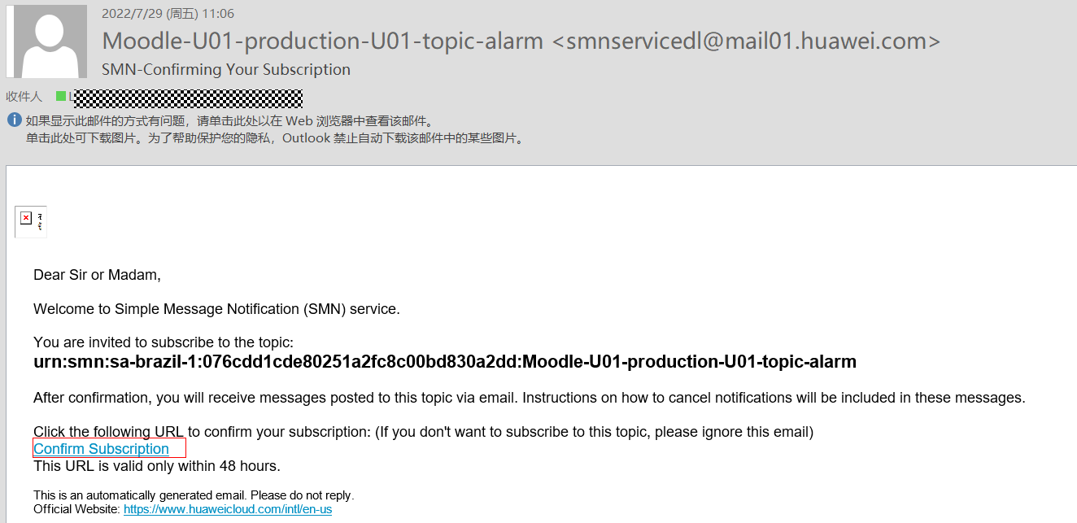

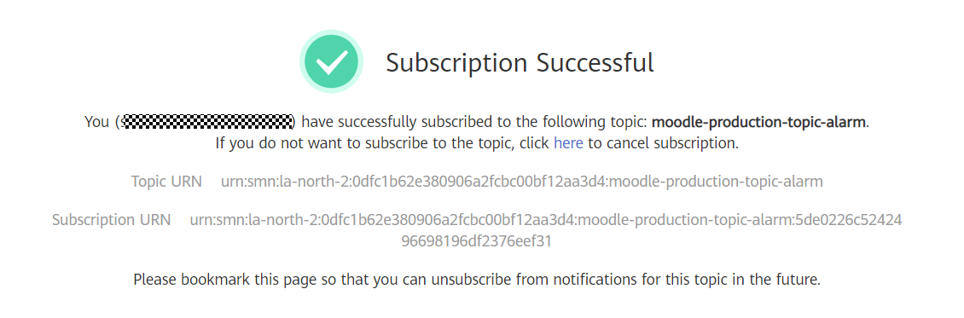

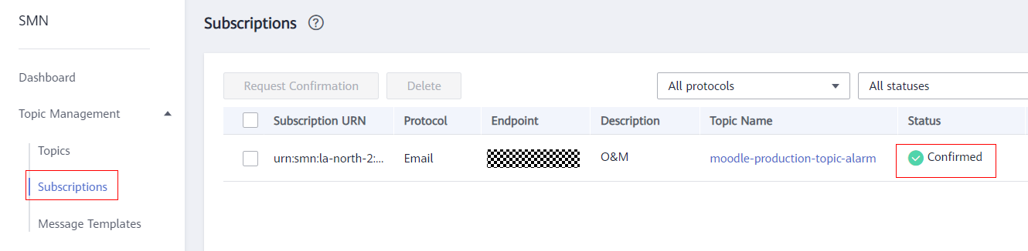

## Moodle Installation

* Obtain the RDS IP address from RDS console

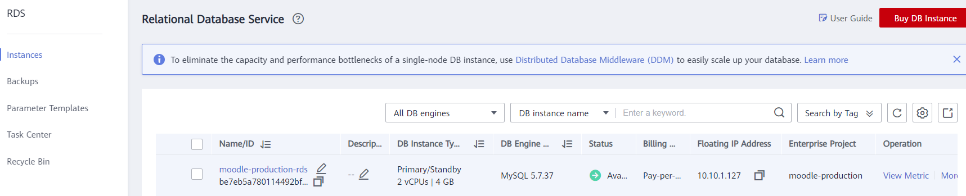

* Open the URL [http://***localhost***/install.php](http://localhost/install.php) in Chrome Browser



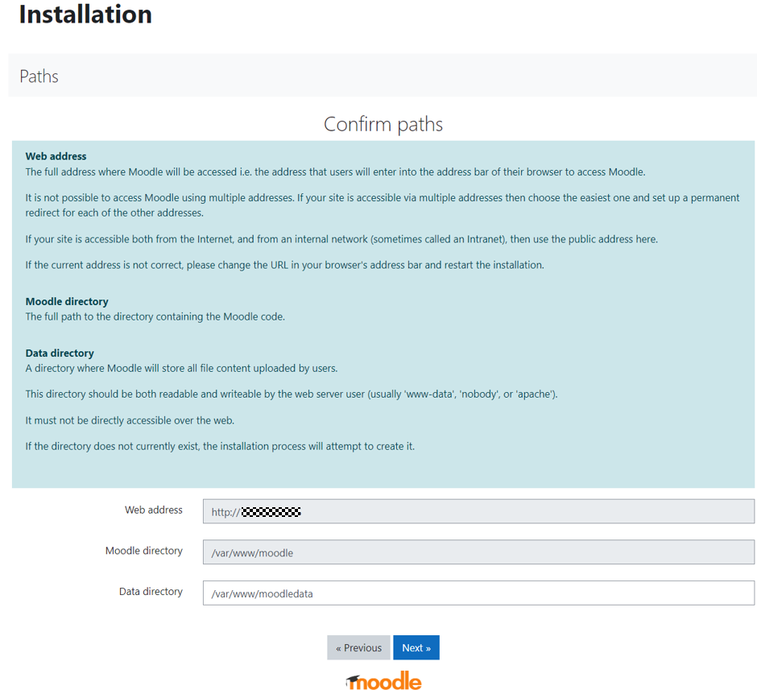

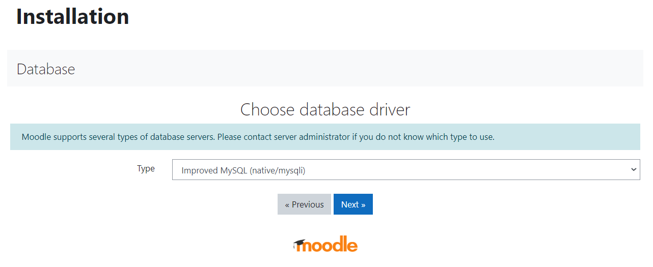

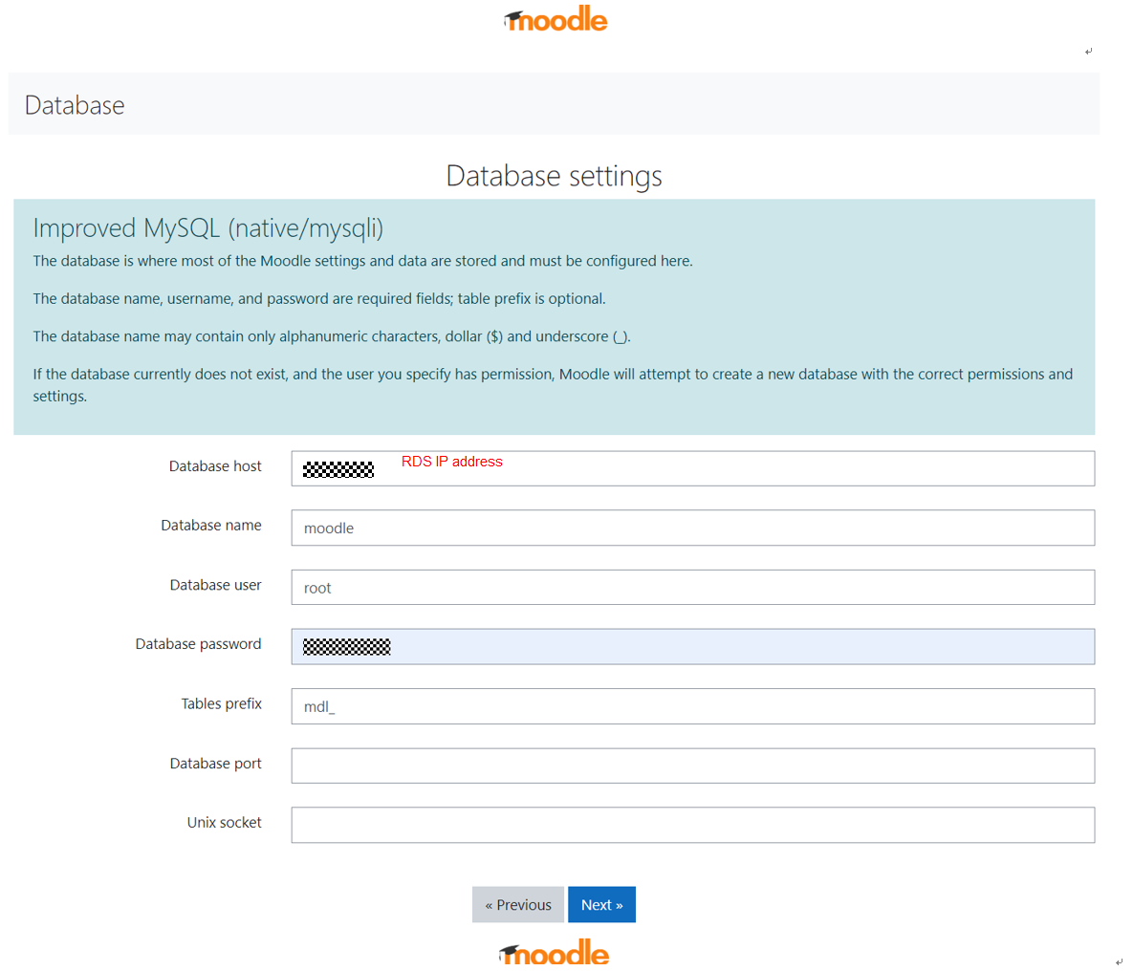

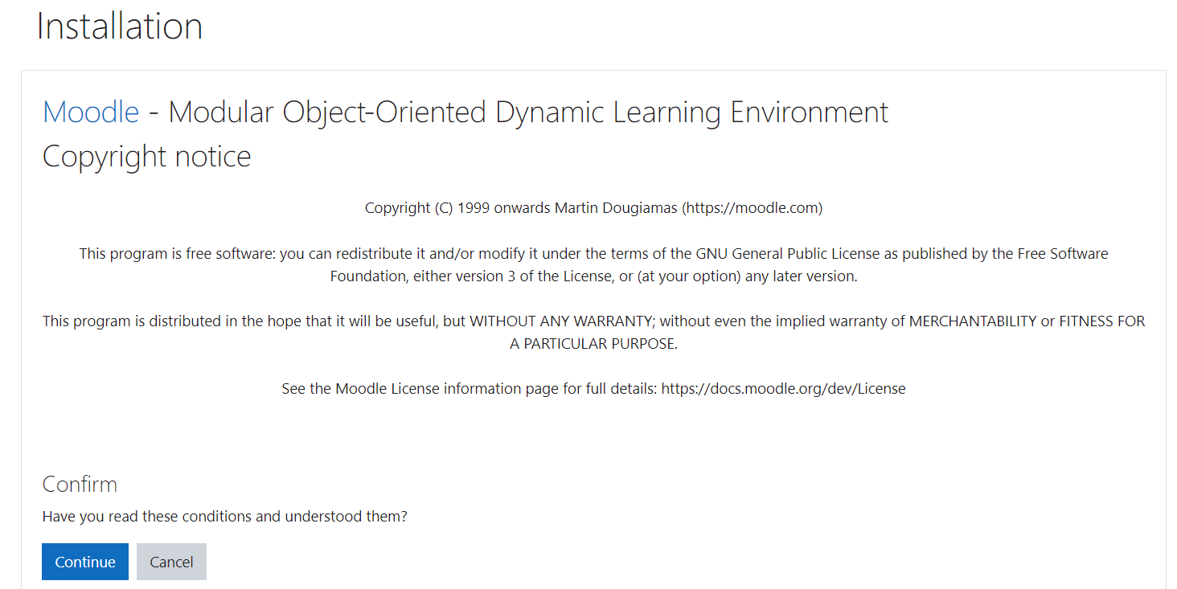

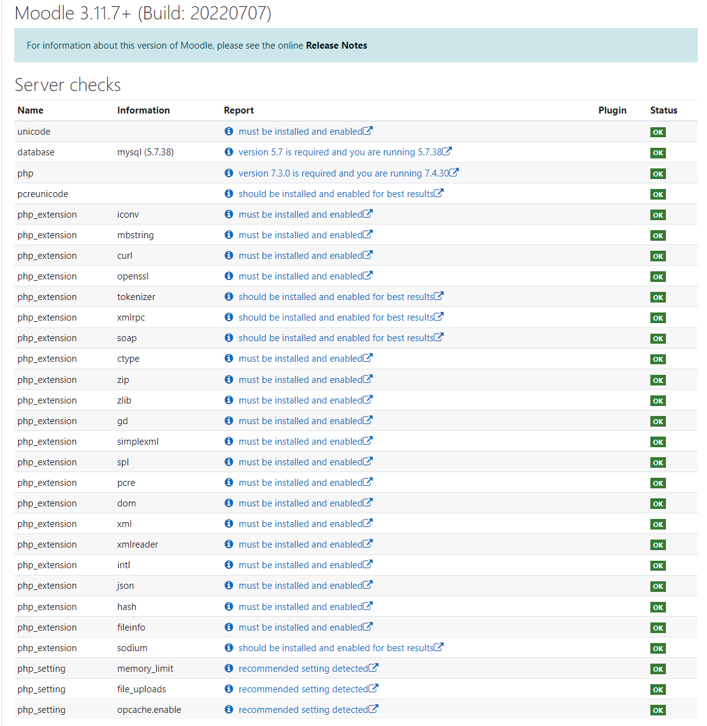

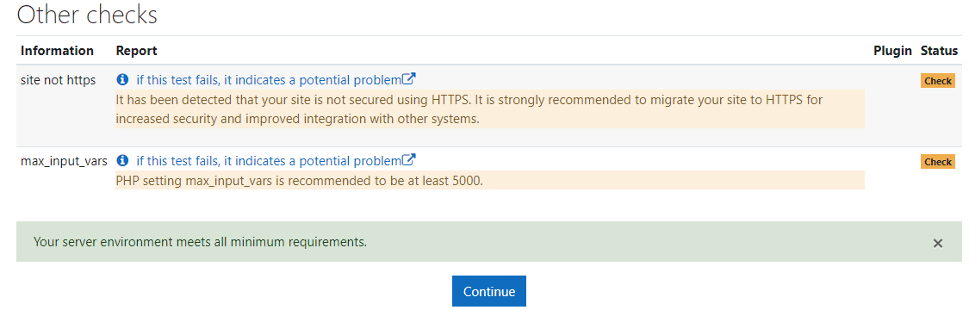

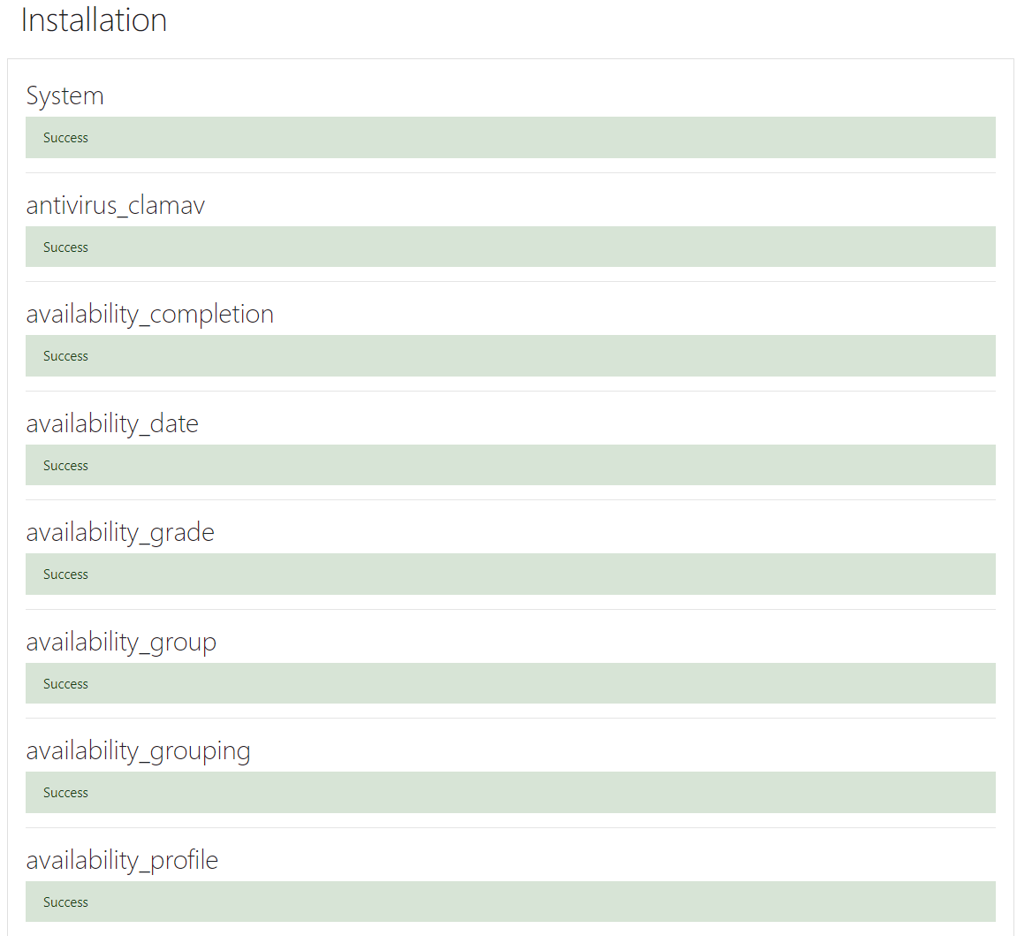

## Moodle Configuration

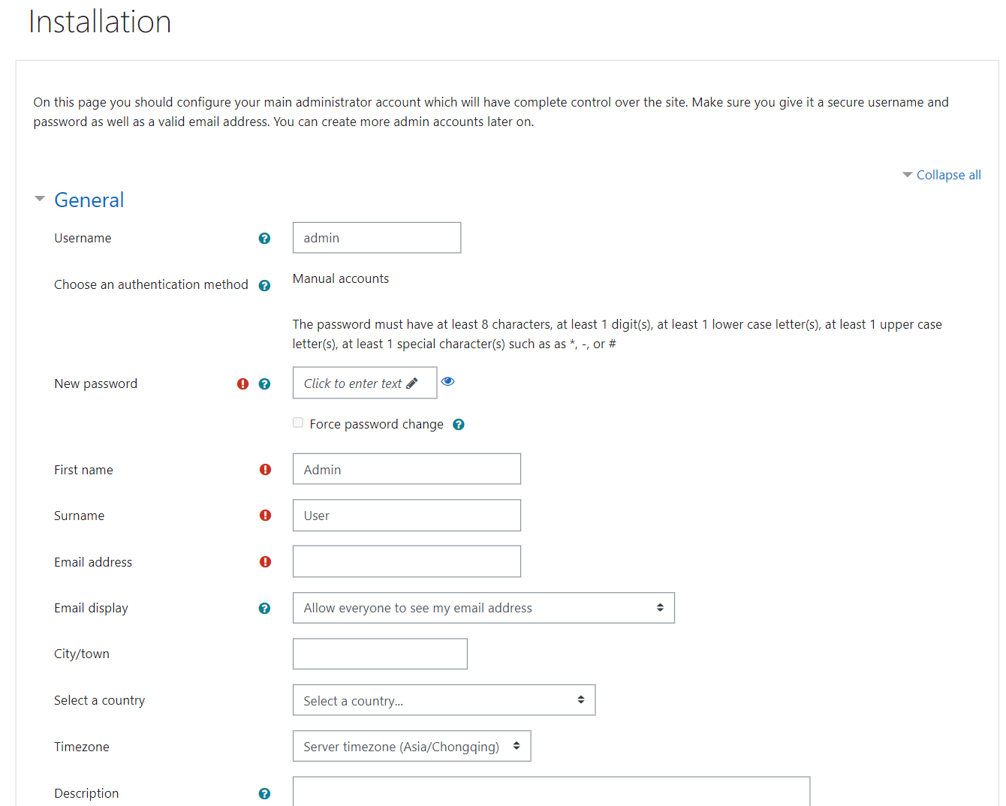

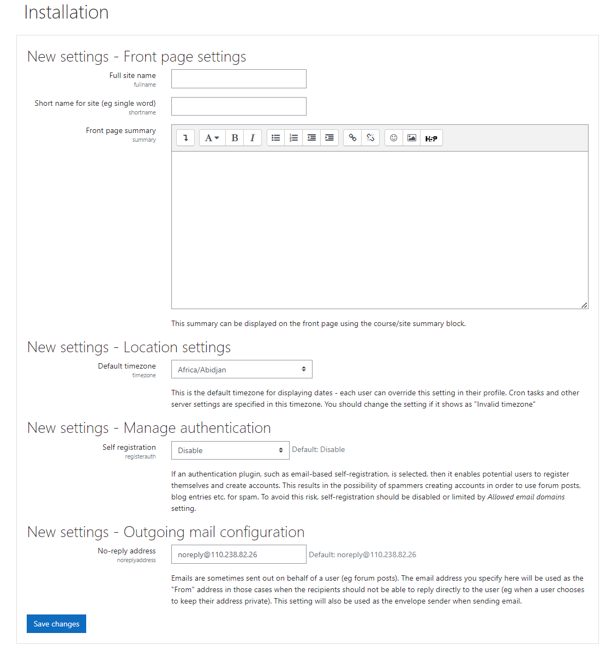

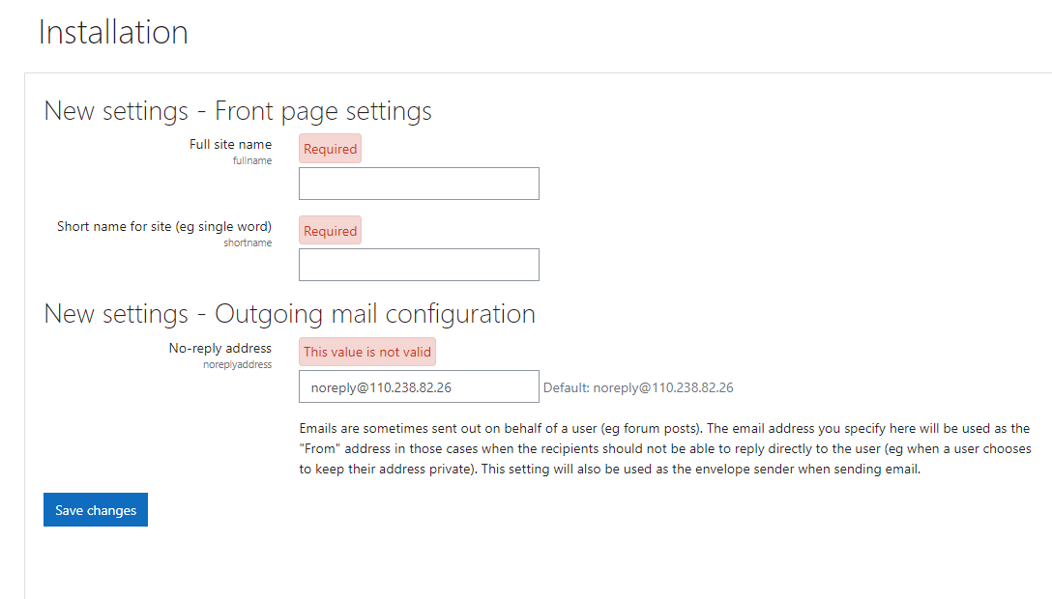

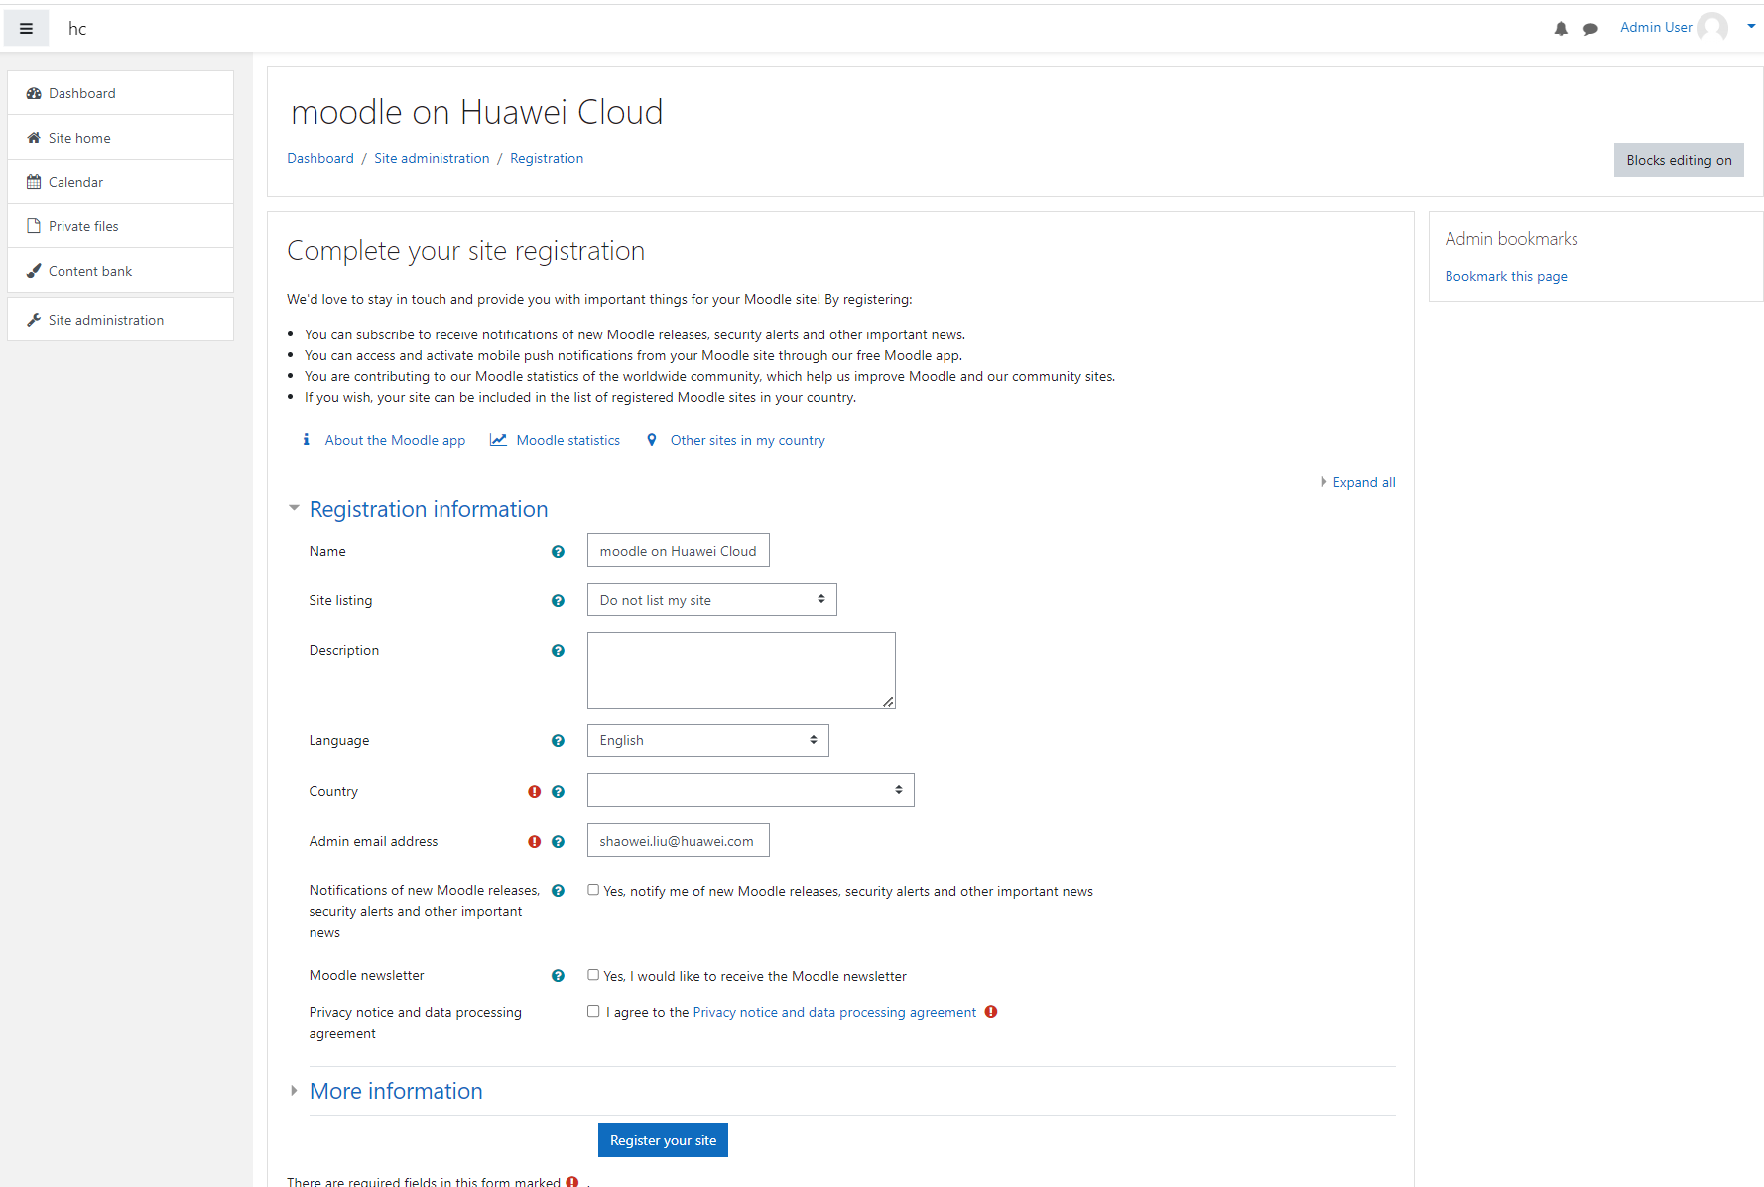

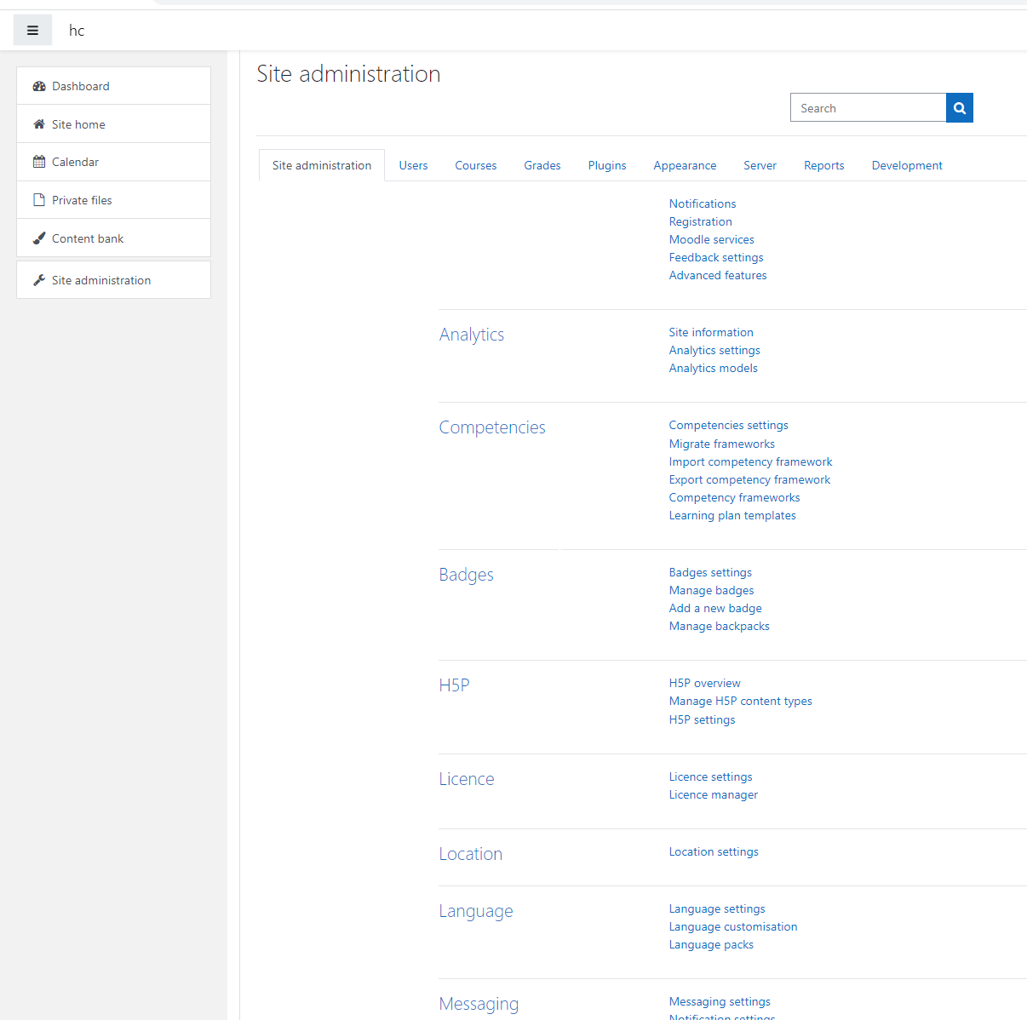

## Cron Configuration

Moodle needs a periodic call to do maintenance work like sending out emails, cleaning up the database, updating feeds, etc. To run the cron every 10 minutes, do the following

# crontab -u www-data -e

Add this line and save.

\*/10 \* \* \* \* /usr/bin/php /var/www/moodle/admin/cli/cron.php >/dev/null

# crontab -u www-data -l

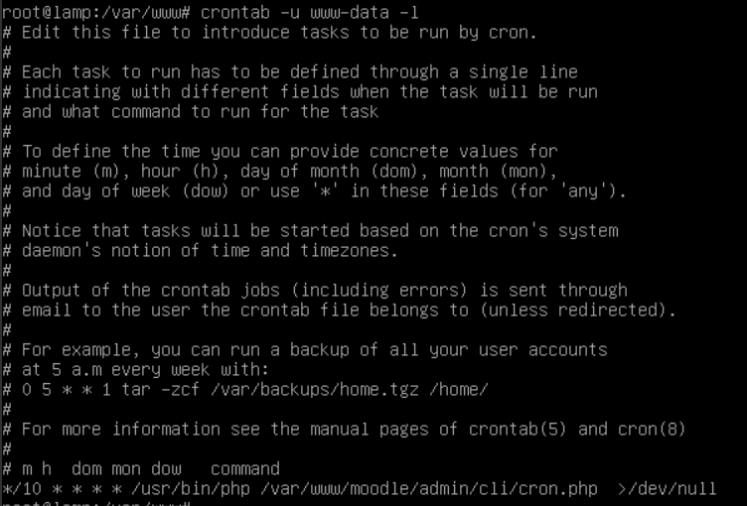

# FAQs

## How to remote login Linux Server via ssh from Windows?

SSH settings in MobaXterm

<https://mobaxterm.mobatek.net/documentation.html#4_1_1>

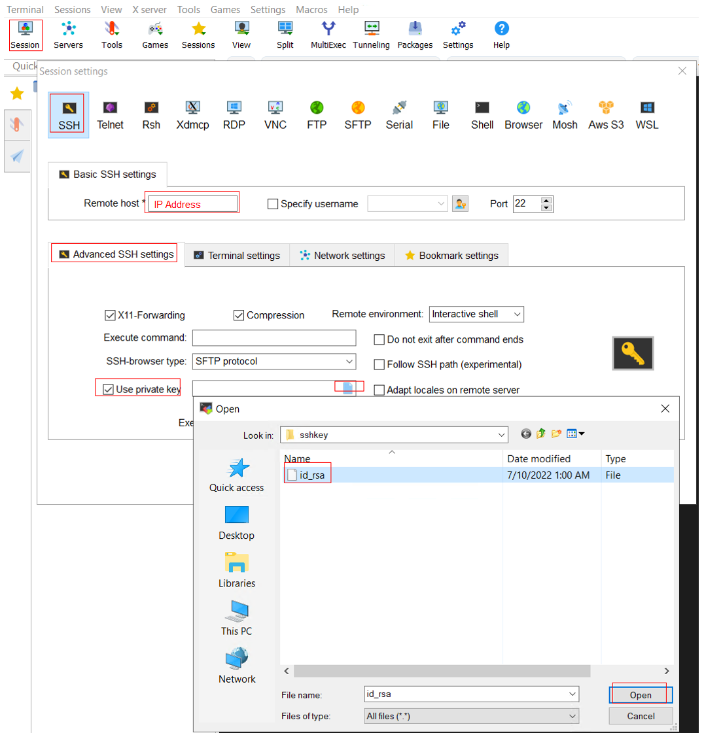

## How to set the root user password for Linux Server

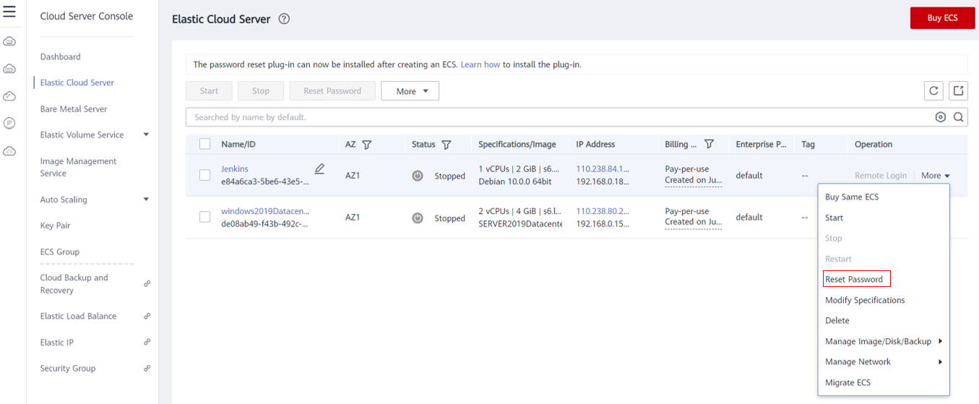

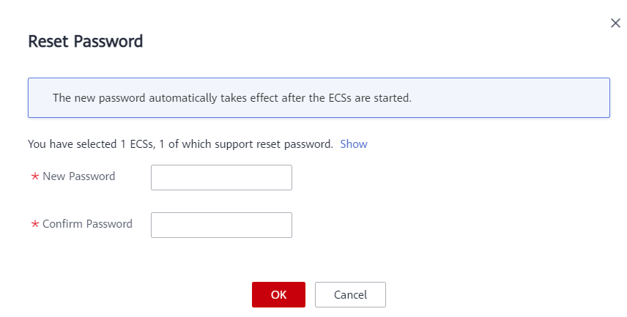

## After I click “Resource Provisioning”, what actions does the tool automatically perform?

* + - 1. A new variables file [*vars.tf*] is generated from the sheet “*Information Collection List*”
      2. The new variables file [*vars.tf*] replaces the old variables file [*vars.tf*] in the [*entry*] directory.
      3. Build the environment *#terraform apply –auto-approve automatically.*

*VB Scripts:*

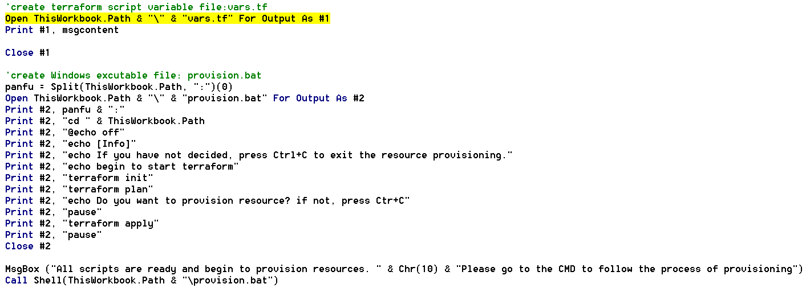

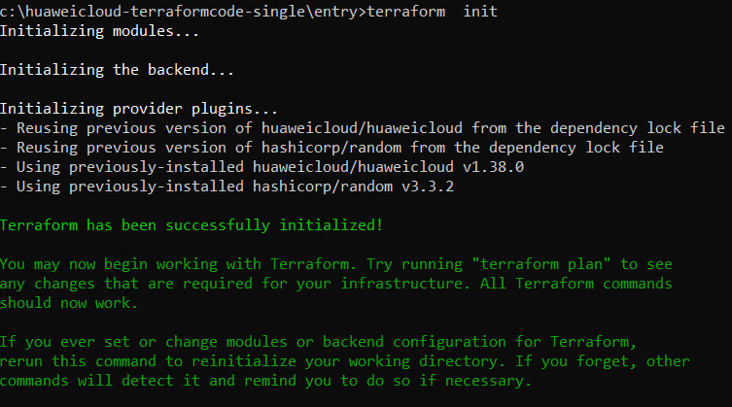

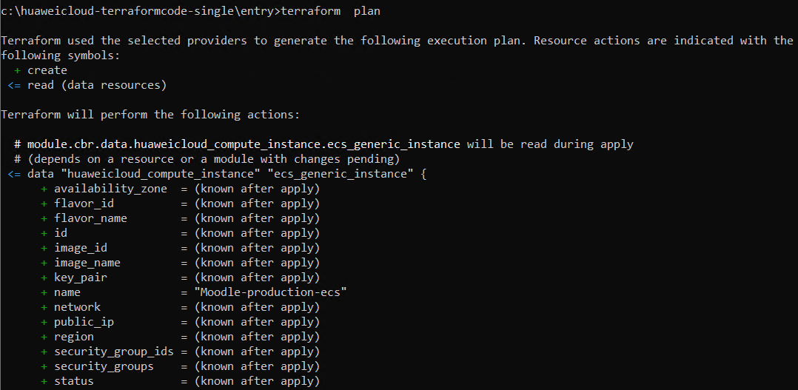

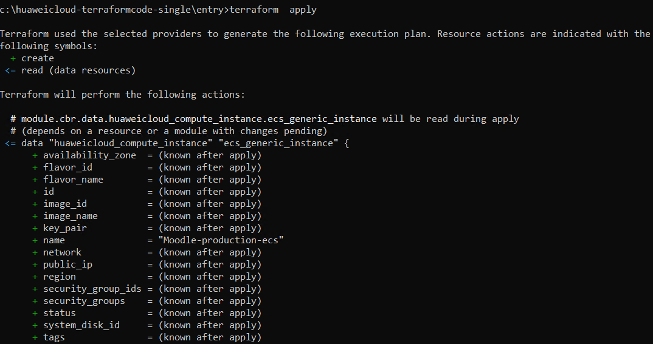

## I want to release all the resources which are created by terraform, how to perform automatically?

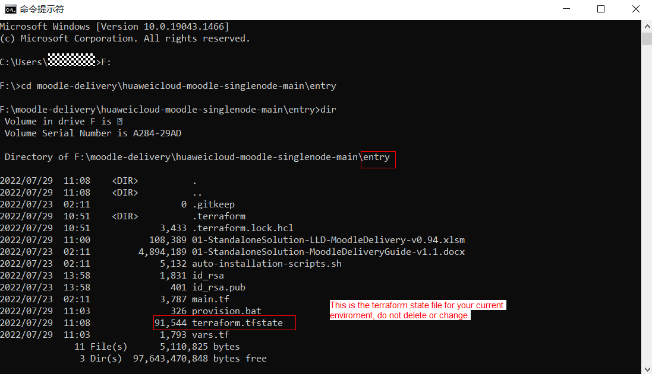



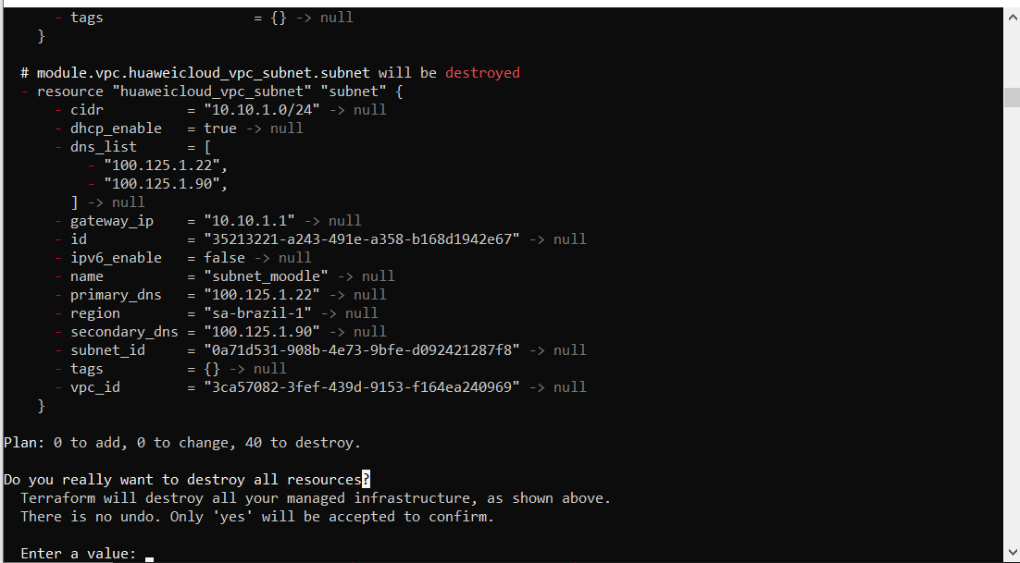

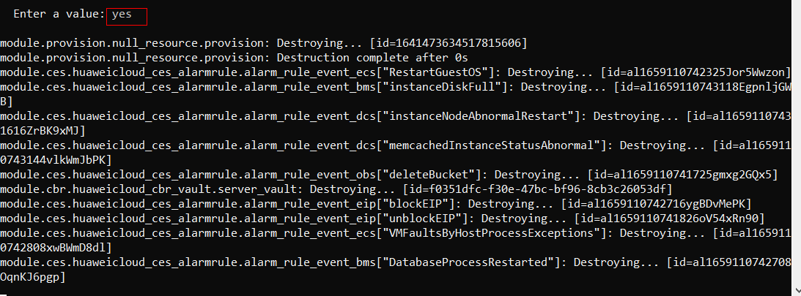

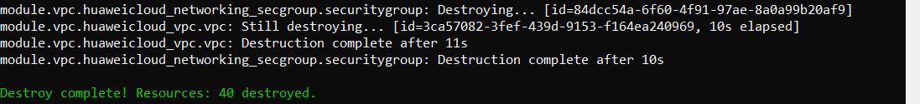

## I don’t have EXCEL in my laptop, and I am familiar with Linux, how to build the environment in Linux OS?

<https://www.terraform.io/downloads>

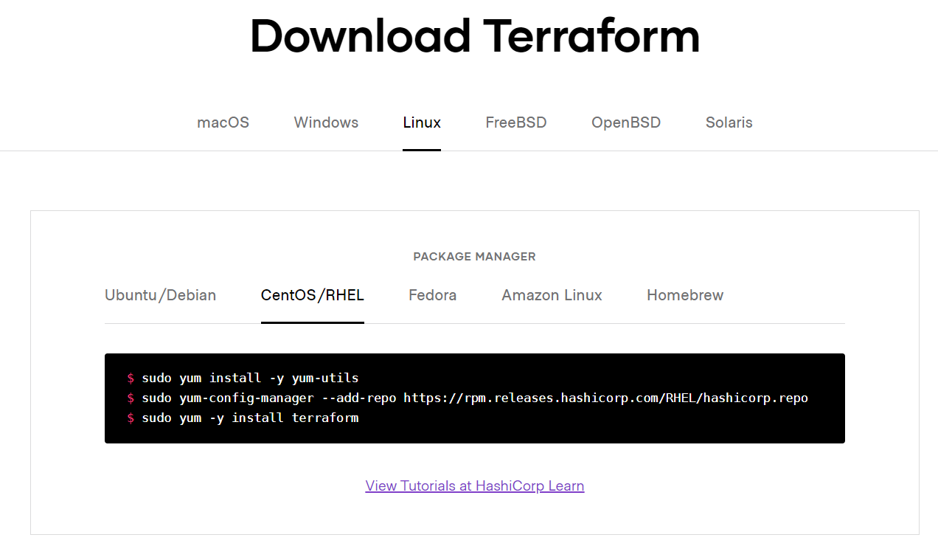

yum install -y yum-utils

yum-config-manager --add-repo https://rpm.releases.hashicorp.com/RHEL/hashicorp.repo

yum -y install terraform

yum -y install git

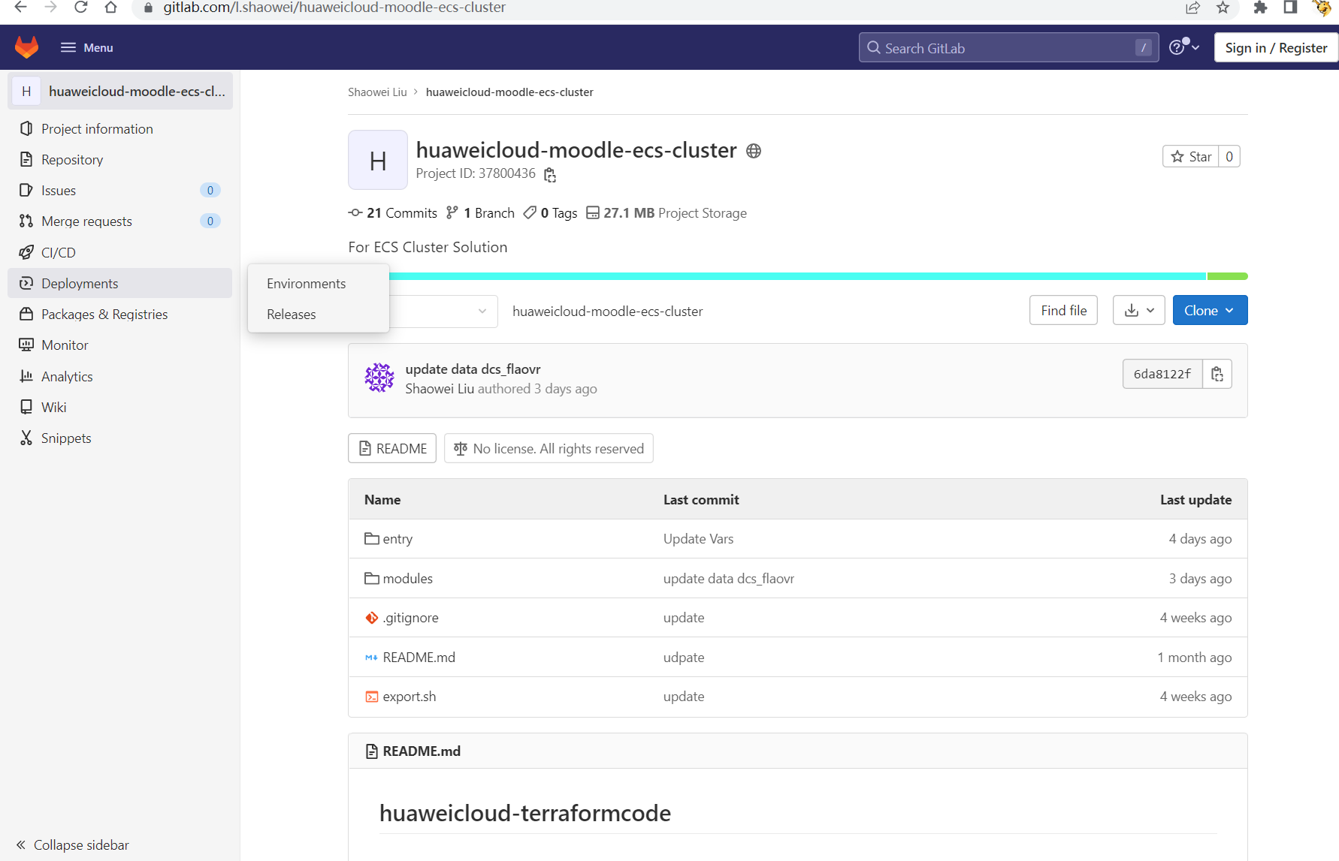

### Clone the branch to local

git clone --branch *main* https://gitlab.com/l.shaowei/huaweicloud-moodle-ecs-cluster.git

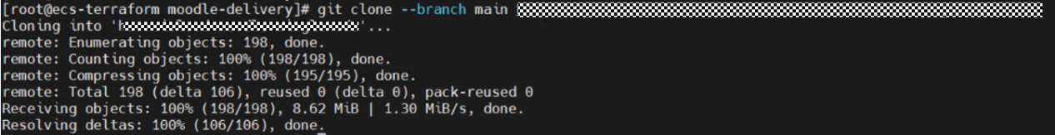

Upload the keys or certificates file to **entry** path:

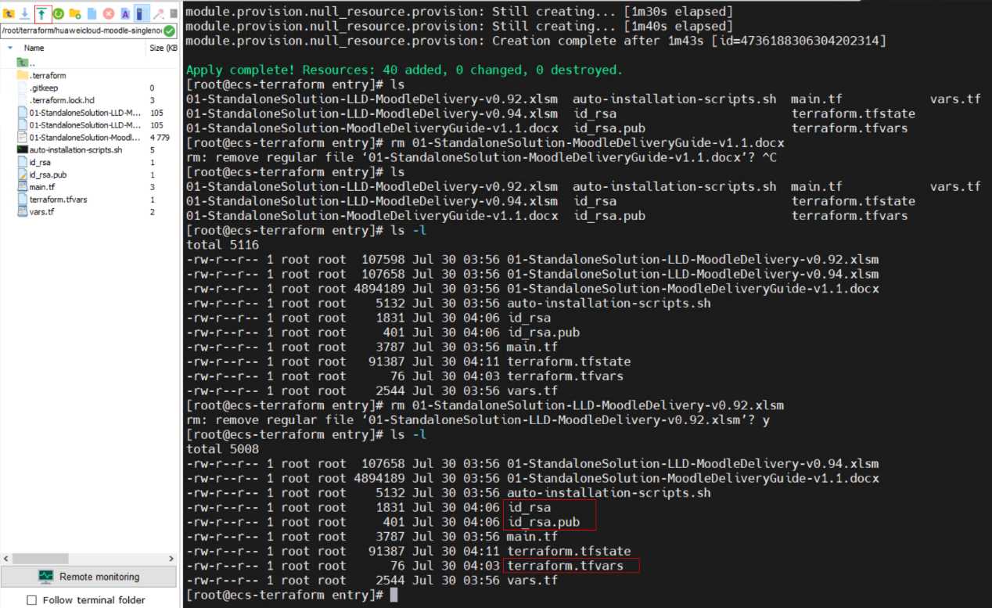

terraform init

terraform plan

terraform apply -auto-approve

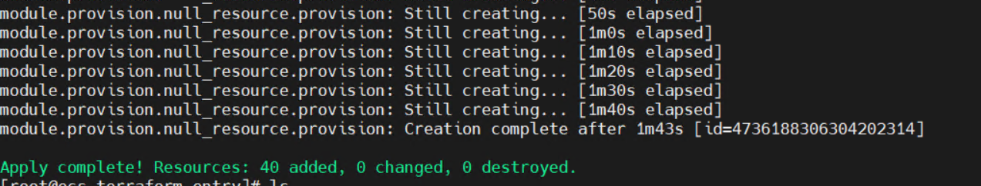

## How to replace the version of Terraform Providers quickly?

Terraform providers release the new version of Terraform monthly, if you want to replace the version number from 1.38.2 to 1.40.2 quickly?

You can use this command

sed -i "s/1.38.2/1.40.2/g" `grep 1.38.2 -rl ./`

For example:

Before:

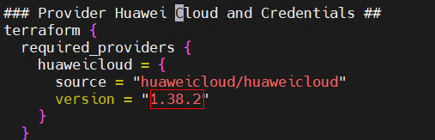

Perform Operation



After:

